FS1 (Nursery) Handbook 2022-2023


Holy Trinity C.E. (C)
Primary School
Burton upon Trent

Holy Trinity Staff

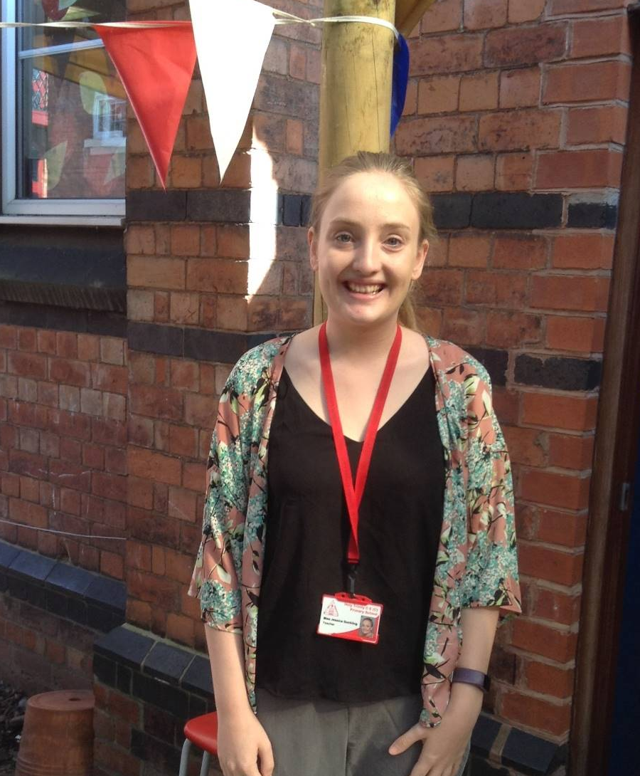
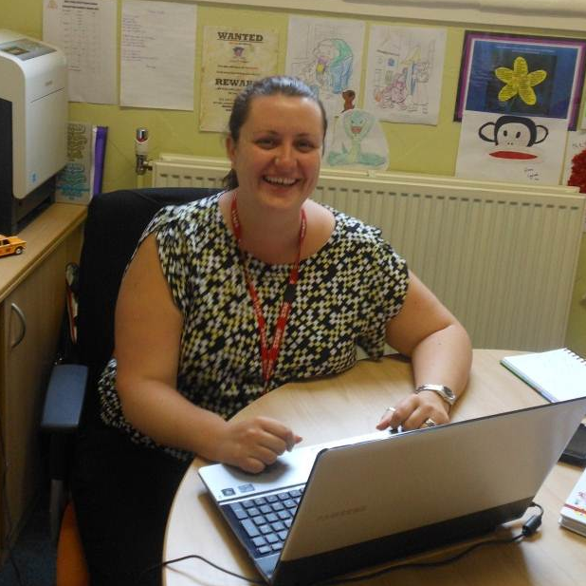

Mrs Nicola Oliphant Miss Jessica Dunkling
Headteacher Early Years Co-ordinator


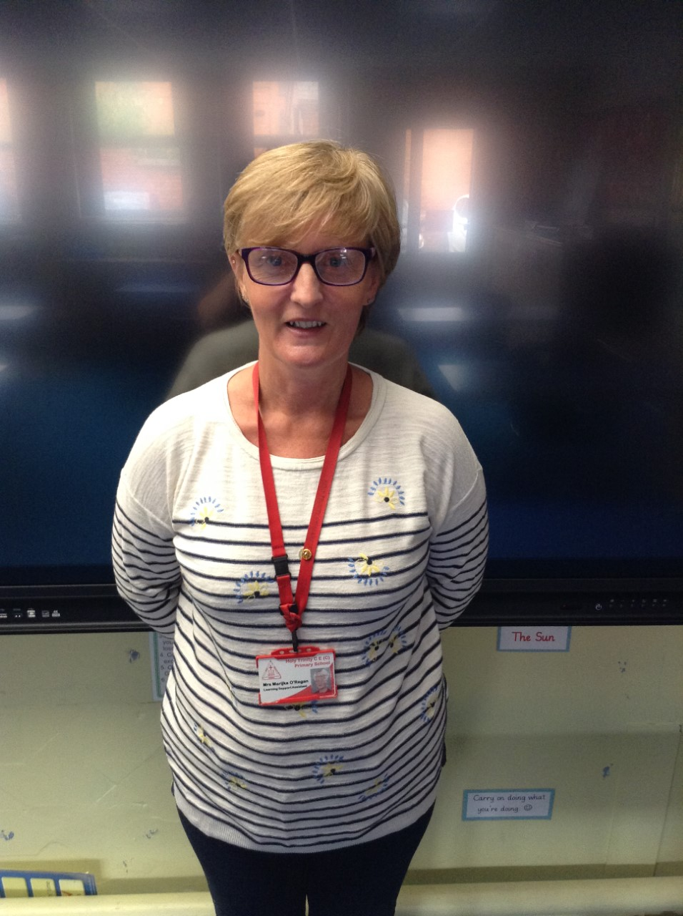

Mrs Marijka O’Regan Mrs Hayley Holden
Learning Support Assistant Learning Support Assistant

Holy Trinity FS1 is a Governor Run, Foundation Stage 1 class (FS1/Nursery) that is part of Holy Trinity Primary School. It has an enclosed outdoor play area to the rear of the building that is shared with the FS2 (Reception) class.

Aims

To provide a caring, positive, secure and stimulating environment in which all children are encouraged to develop their full potential. Understanding that children develop and learn at different rates.

To plan and carry out a differentiated curriculum which is child-centred, broad, balanced, relevant and meets the requirements of the Early Years Foundation Stage Framework. Keeping in mind that every child is a unique child, who is constantly learning and can be resilient, capable, confident and self-assured.

To develop positive working relationships between home, school and the local community. In turn ensuring children learn to be strong and independent through positive relationships

To enhance and nurture each individual’s self-esteem and their ability to value their own and each others’ worth and talents.

To offer a wide range of high quality experiences which enable the children to acquire concepts and skills which help them to understand themselves, their culture and the world in which we live.

To develop the natural curiosity and willingness to learn that young children exhibit and to foster positive attitudes to learning.


FS1 Sessions

Times
During term time Monday - Friday from 8:40am – 3:30pm
Morning Nursery Session – 8:40am – 11:40am
Lunchtime Club – 11:40am – 12:30pm

Afternoon Nursery Session – 12:30pm – 3:30pm

Punctuality
Please ensure you arrive on time for the start of the session and that you collect your child on time. This is an important habit for your child to learn and can affect their confidence and self-esteem if they are consistently late or left waiting when the rest of the group have returned home.

School Terms and Holidays
A parent newsletter is issued on a half-termly basis with topic information and dates relevant to FS1. A whole school newsletter also comes out almost fortnightly with whole school information.

Lunchtime Club (Governor Run) FS1 sessions
We operate a lunchtime club from 11:40am – 12:30pm every day. The cost of the session is £4.50 and includes a hot school dinner (this is not included in the 30 hours of funding). Lunchtime club is a good way of getting the children used to the routines they will be following in FS2 and allows them to continue to develop social skills. It is also an opportunity to try school dinners and see what it is like to stay at school for a longer period of time.

Morning/Afternoon (Governor Run) FS1 sessions
Morning/afternoon sessions are also available from either 8:40am- 11:40am or 12.30pm – 3.30pm Monday – Friday respectively. The cost of a three-hour session and lunch is £18.75 if it is an add-on to the session your child already attends. You can also access the afternoon sessions the term after your child turns three and can use their 15 hours of free childcare. Please contact Mrs Buxton in the school office to book your child’s place at lunchtime club or for additional sessions. All payments are to be made on ParentMail (log in details will be provided).

Paying 2 & 3 year olds
If you would like your child to attend our FS1 setting but aren’t eligible for Think 2 funding or Rising 3 funding (before the start of the term after your child’s 3rd birthday), paid places are available. A full day session including lunch is £33. If you book for a full week, we offer a £6 reduction per day, taking the daily cost to £27 or £135 for the week. A half-day session either morning 8:40am-11:40pm or afternoon 12:30am-3:30pm is £14.25, and a lunch hour can be added to either session at a cost of £4.50. Again these are flexible and please speak to a member of the office or Early Years team if you have any questions.

Please be aware that the amount of sessions available to you may vary throughout the school year depending on the FS1 numbers.

Induction Procedures

Stay and Play. You and your child will be invited to school for a Stay and Play session the term before they are due to start. You are welcome to leave children if you would prefer.

September intake for the Morning FS1 If your child has not attended the Afternoon Nursery sessions they will be invited into school for a morning in a smaller group to allow them to settle. This also gives staff the chance to get to know your child in a smaller group before all the children start.

Other Information


Behaviour
At Holy Trinity FS1 we work together to ensure a consistent, positive approach to behaviour. We expect our children to be polite and to behave in a sensible and thoughtful way. Positive rewards are offered to our children when they model good behaviour in the form of praise, stickers and certificates.

School Uniform
Children who attend Holy Trinity are encouraged to wear school uniform to allow the children to develop a sense of belonging. Please ensure all your child’s clothing is clearly labelled. School uniform can be ordered from three suppliers. Please encourage your child to be independent and hang up their own coats on their labelled peg.

We ask that you send your child to school with a P.E. bag containing at least one complete change of clothing and a pair of pumps for occasions when they may get wet during activities or for those times when accidents occur. This set of clothing does not need to be school uniform.

Health
There will always be a paediatric first aider available in school when needed. Should your child have an accident in school it will be recorded in the accident book and you will be informed by a member of staff who will ask you to sign the book. If your child is unwell or something more serious than a graze or bruise occurs you will be contacted straight away by a member of staff. Please ensure we always have an up to date telephone number to contact you on.

If you are aware that your child is unwell please do not send them to school. If your child has been sick or has had diarrhoea, please keep them off school for 48 hours from the last episode. Please contact school on the first day of illness and let the office know when your child is expected back to school.

If your child requires medicine during school hours please ask for a “Medicines in School” form from the school office.

FS1 Fund
FS1 Fund for the FS1 sessions will be £2.00 per week for the purchase of cookery items and craft materials. This fund is also used to purchase extra resources to ensure creativity in all topics and to pay for our moo music – music and dance sessions.

Snack time
All the children are entitled to a carton of milk and fruit during each session. At the beginning of the year milk monitors are used to give out milk with the children working towards selecting their own milk and putting their own straw in their carton by the end of the year. We expect the children to show good manners during snack time by saying please and thank-you and demonstrating good table manners.

FS1 Curriculum

The activities that the children enjoy at Holy Trinity FS1 are carefully planned using the Early Years Foundation Stage Framework. The Framework covers three prime areas of learning and four specific areas of learning:

Prime Areas
Personal, Social and Emotional Development Children’s personal, social and emotional development (PSED) is crucial for children to lead healthy and happy lives, and is fundamental to their cognitive development.

Communication and Language The development of children’s spoken language underpins all seven areas of learning and development. Children’s back-and-forth interactions from an early age form the foundations for language and cognitive development.

Physical Development Physical activity is vital in children’s all-round development, enabling them to pursue happy, healthy and active lives.

Specific Areas
Literacy It is crucial for children to develop a life-long love of reading. They will be taught the early reading skills including language comprehension and word reading and transcription (spelling and handwriting) and composition to support early writing.

Mathematics Developing a strong grounding in number is essential so that all children develop the necessary building blocks to excel mathematically. Children should be able to count confidently, develop a deep understanding of the numbers to 10, the relationships between them and the patterns within those numbers.

Understanding the World Understanding the world involves guiding children to make sense of their physical world and their community.

Expressive Arts and Design The development of children’s artistic and cultural awareness supports their imagination and creativity.

Phonics
To support the teaching of communication, language and literacy a phonics programme is used in school.

Themes
The activities in FS1 are planned around themes. The themes for the term will be outlined in the FS1 newsletter given at the beginning of the term. The themes used within FS1 will reflect the diversity of the curriculum and interests of the children.
Some examples of themes we may choose are:

Nursery Rhymes
Traditional Tales
Celebrations
The Jungle

Ourselves
Our senses
Spring
Animals
Transport
Pirates People who help us

Assessment
Assessment in FS1 begins during the stay and play sessions. The staff at Holy Trinity will record what they observe as your child joins in with every day routines and activities as well as when they are playing and working. They record this in the form of photographs, comments on post-it notes, comments on look, listen and note record sheets and examples of your child’s work. This will show the progress they have made while they are in FS1. It is collated in your child’s Learning Journey.

There will be opportunities during parent and teacher meetings for parents and children to make comments for the profiles. Parental contribution to your child’s learning is important to us and we will provide opportunities through home learning and discussions with you to support this.

Your child’s profile will then be passed on to their FS2 Teacher at the end of the year.

Concerns or complaints
If you have any concerns the staff will be available to see you before or after the session. We will come and speak to you if we are worried about your child in any way or if any incidents or accidents have occurred during the session. We do also endeavour to inform you straight away of any amazing work or comments your child has made during the day.

We are sure you will be happy with the hard work that takes place in our FS1 setting at Holy Trinity but should you have any concerns please speak to the class teacher initially to resolve any issues. Should you need further assistance please see Miss Dunkling the Early Years Co-ordinator.


