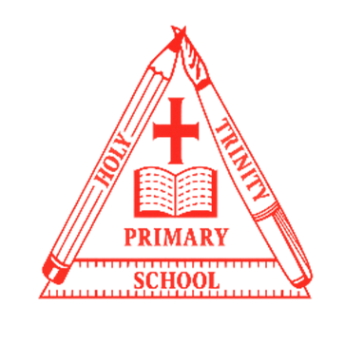
Year 2
Curriculum NEWSLETTER
LOGO
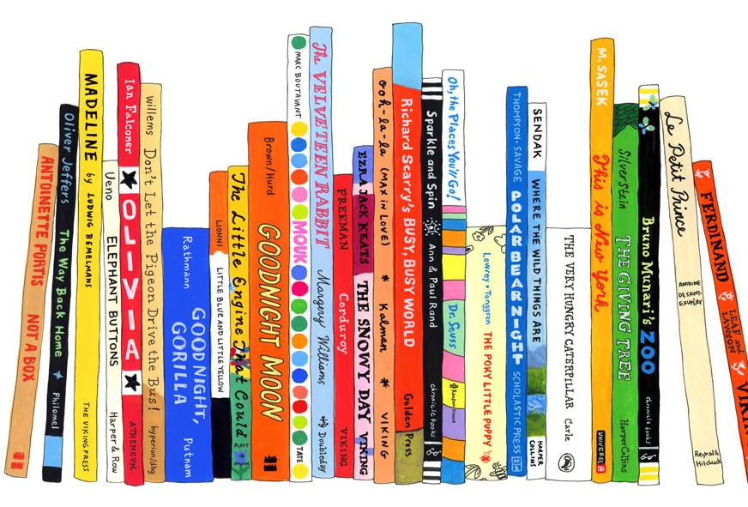
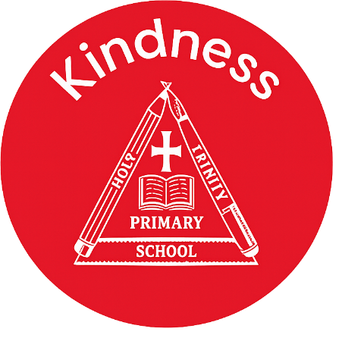
English Learning
In reading, we will continue to develop our reading skills and fluency using VIPERS across a range of texts. In English we are exploring and writing our own poetry and writing our own dragon adventures using expanded noun phases, prepositions and a range of interesting sentence openers.

Class teacher’s Message
Maths Learning
Our Maths lessons will begin by focusing on time; O’clock, half past, quarter to and quarter past as well as telling the time to 5-minute intervals. We will then move on to Statistics where we will explore tally charts, block diagrams, pictograms and tables. We will end the half term with position and direction.

“There is more treasure in books than in all the pirate’s loot on Treasure Island.”
– Walt Disney

Welcome to this half-term in year 2

Teachers and adults working with the children are Miss Bora and Miss Park

INSIDE THIS NEWS

Children will need water bottles, sun hats and sun cream as the weather improves – this is especially important on Friday’s when we go to the Washlands.
It’s important to fail in our learning!
Reminders

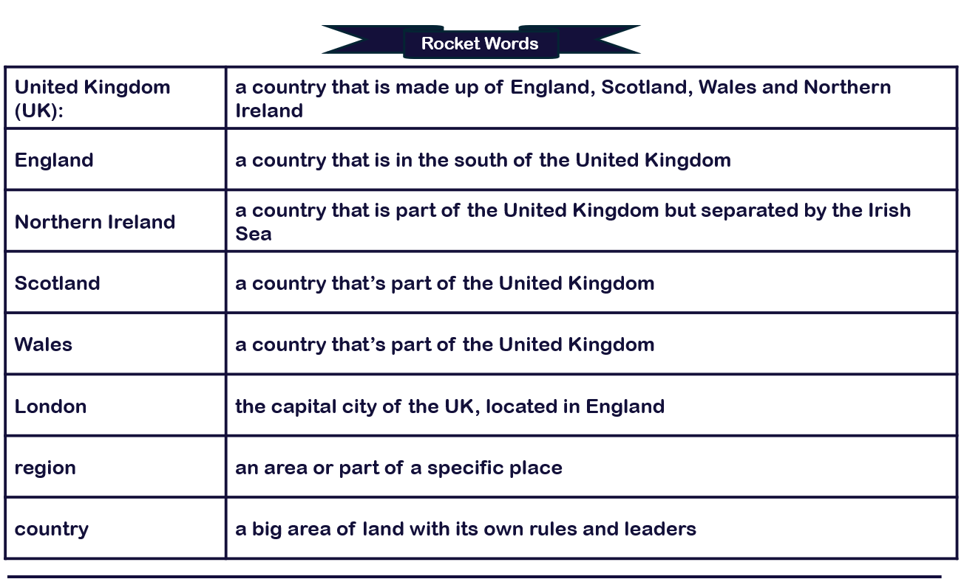
beyond living memory inventor lifetime source
Key Rocket Words
Geography Learning – The United Kingdom
This unit builds on children’s knowledge of the UK from Year 1. The children will study each country of the UK in more depth, identifying capital cities and key geographical characteristics. Over the unit, the children will work towards producing a guide to the United Kingdom.

Science Learning
In Science, We are revisiting Living things and their habitats – Habitats around the world. The children explore and compare the differences between things that are living, dead, and things that have never been alive; describe how different habitats provide for the basic needs of different kinds of animals and plants, and how they depend on each other.

Spelling test Day
Key Days
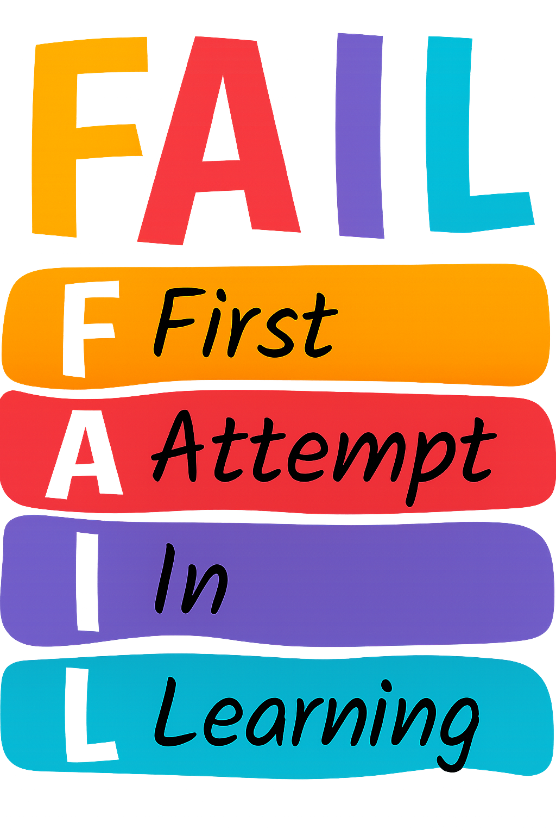

PE Day/s

- Friday
- Monday and Friday

