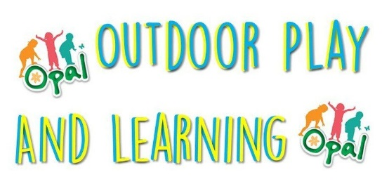
Outdoor Play and Learning (OPAL) Resources
Friday 17th November 2023
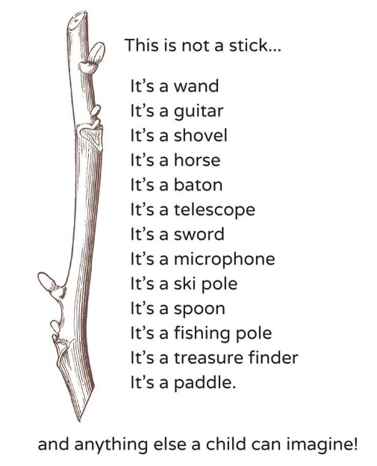
We are wondering if you could help us with our Opal Playtime equipment please? Below is a list of dream items we’d love to be sourced for the children to play with at school We will be holding a collection week beginning Monday 27th November. Please don’t send anything before this date
I will give a warning at this point too... Opal Playtimes is all about the joy and love of playing. It allows the children to explore, engage and risk take. We will carry out risk assessments to support their play – but we want to them to have control of this in order for them to truly play and take risks. We may have a few extra bumps and scrapes, we may have some wet and dirty clothes that come home each day. We want their playtime in school to be as memorable as we can possibly get it…

Fabricated Loose Parts (see list A) are anything man-made that is not a toy or a specific piece of sport equipment.
Natural Loose Parts (see list B) is any moveable natural material that children can transport, mix, and construct with or incorporate into their play.
Any donations of loose parts should be dropped off at the school gates. Please make Miss Dunkling, Miss Smith, Mrs Wells, Mrs Stewart or myself aware of any donations so that they can then be stored in our boxes.
Whilst we will thoroughly check all items to ensure their safety, it would be appreciated if you could check that the items are safe enough to play with i.e. pockets, bags should all be cleared out, cables cut-off.
We are also looking for small world toys e.g. cars, dinosaurs, farm animals or other small figures so that the children can also play with these. If you have any old/spare wellies you would like to donate to the school (all shapes and sizes!) these would also be gratefully received.
Fabricated (List A) | Natural (List B)
Astro Turf Off cuts | Pine cones
Bread, milk, bottle and grocery crates | Sand (Washed dredged not 'Sharp')
Brief cases | Sea Pebbles
Buggies, push chairs | Shells
Cable drums
Keys – Any shape and size
Carpet samples
Carpet squares
Cuddly Toys
Fabrics – Preferably parachute type materials and as colourful as possible
Foam pipe covers and noodles
Guttering – any size and shape
Hoses and pipe
Keyboards
Metal pots, pans, trays etc. especially catering sizes
Netting - fishing, cargo, football
Office removal crates
Old clothes, jackets, overalls, hats, bags
One Ton Dumpy Bags Pallets – must be up together
Pegs – preferably market or garden type larger pegs or wooden clothes pegs
Plastic trugs and bins, water carrier
Ropes, string, wool and ties
Small wheelie bins
Sofa and chair cushions
Scaffold- Preferably small scaffold tubing but can by lengths that we can cut down
Steering Wheels
Suitcases/Briefcases of all sizes
Tubes of all kinds
Wooden block and off cuts
Buckets and watering cans
Metal saucepan lids – all sizes and conditions
Wellies

Thank you all so much for your help and we look forward to the items arriving in school for the children to play with
There will be more information to follow at a parent’s session later in the academic year when you will be invited to come and play with your children. We are really excited about this project and hope that you will support us in our efforts to improve playtime for all children.

Yours sincerely

Mrs Nicola Oliphant
Miss Dunkling
Mrs Wells
Mrs Stewart
Miss Smith

The Opal Play Team

