
Year 3
Curriculum NEWSLETTER
LOGO


Maths Learning
In Maths, we will be learning to multiply and divide. We will focus on learning the multiplication and division facts for the 3, 4 and 8 times tables, reheasring these regularly so that we are able to recall them quickly and fluently. We will apply this knowledge to word problems and reasoning questions.
English Learning
In English, we will be creating fictional narratives and non-chronological reports. Our independent pieces of writing will be inspired by the Talk For Writing units Alfie’s Star and Marvellous Monsters. We will work on our sentence structure and descriptive language techniques. We will also learn to use fronted adverbials to vary our sentence openers. In reading, we will continue to develop our decoding, fluency and comprehension skills. We will be reading Look up! by Nathan Bryan.
“The more that you read, the more things you will know. The more that you learn, the more places you’ll go.”
– Dr. Seuss

Welcome to this half-term in Year 3!

Teachers and adults working with the children will be Mrs Quinn, Mrs Fox and Miss Whitt.

INSIDE THIS NEWS

History – Why did the Romans invade and settle in Britain?
In History, we will learn about the different reason for the Roman invasion of Britain and why they chose to settle here. We will learn about the Celts response to the Roman invasion and use artefacts to make deductions about the lives of Roman soldiers in Britain. Finally, we will discuss the meaning of legacy, identifying how the Romans changed Britain.
It’s important to fail in our learning!
Reminders
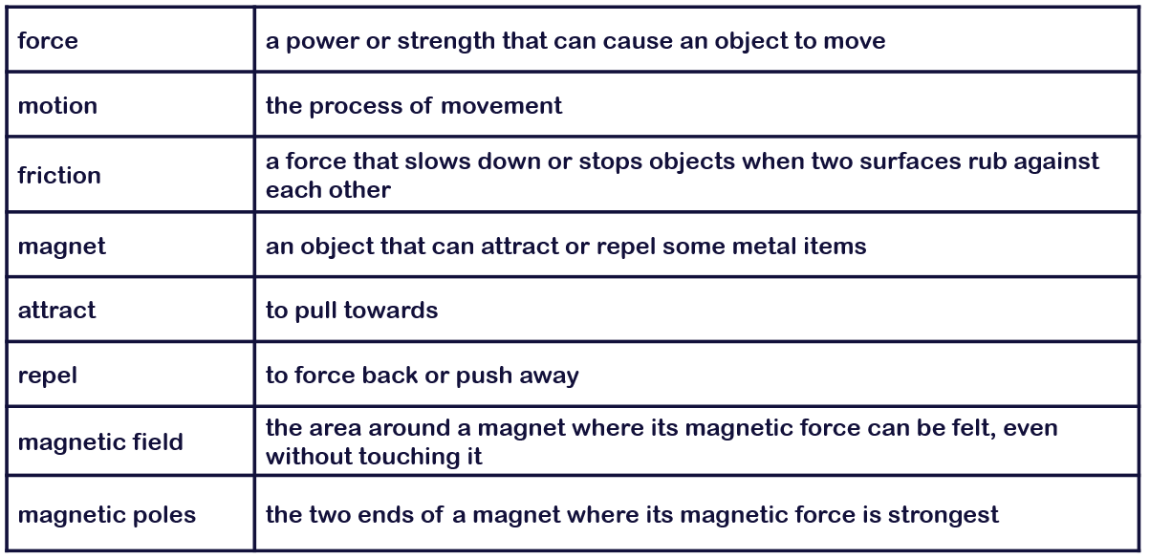
Key Rocket Words
Science Learning
In Science we will be learning about forces and magnets. We will learn how magnetic forces can act at a distance, observe how magnets attract and repel each other and compare group everyday materials based on whether they are magnetic or not. We will also describe magnetic poles and compare how objects move on different surfaces and why.
Spelling test Day
Key Days
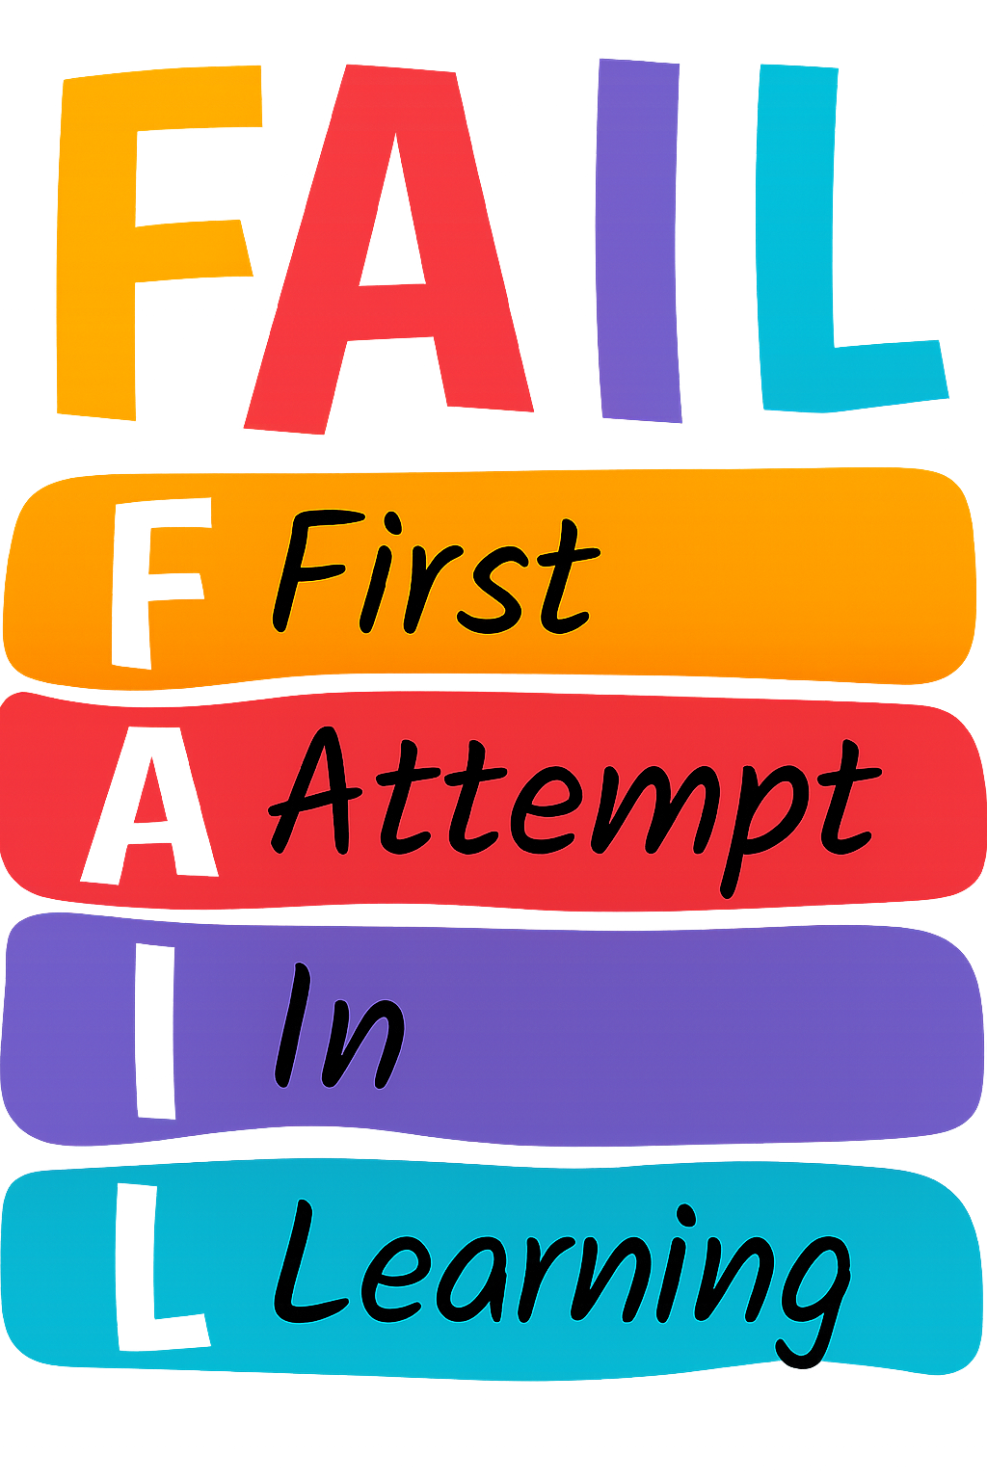

Please ensure you are practising your times tables on TT Rockstars and reading daily! Reading records need to be brought into school every day.

PE Day/s

- Thursday
- Tuesday and Wednesday

