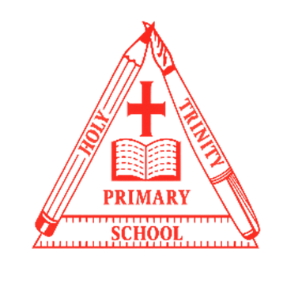
Curriculum NEWSLETTER
Summer Term 2
Year 5
LOGO

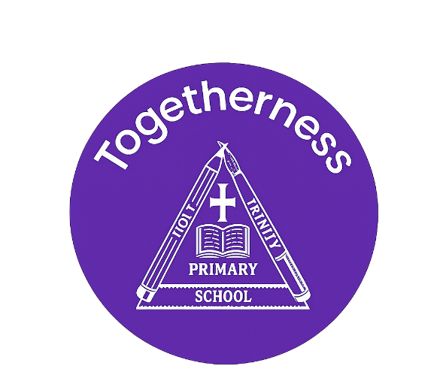
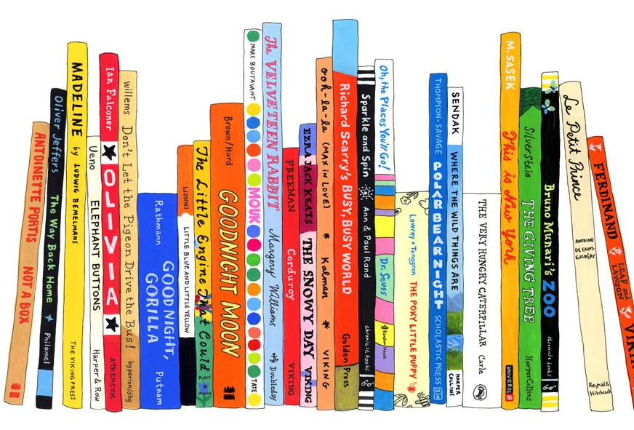
Welcome to this half-term in year

Teachers and adults working with the children:
Mr. Garb

Miss Tyler (PPA cover)
Mrs. Wain (Fluency Fridays)
Class teacher’s Message
Maths Learning
In Maths, we will consolidate place value knowledge. We will also learn about geometry and measurement, being able to translate using coordinates and convert between units of measurement.
On Fridays this half term we will be focusing on arithmetic to secure key skills.
English Learning
This half term, we will be exploring wishing tales. We will be understanding what a wishing tale is, before writing our own. We will explore grammatical features through drama, shared writing and short burst writing.
We will continue to develop our key VIPERS skills through focused guided reading sessions.
“Reading is a passport to countless adventures.” – Mary Pope Osborne

INSIDE THIS NEWS

Reminders
Swimming is on Tuesday.
Bring in your reading records every day!
It’s important to fail in our learning!
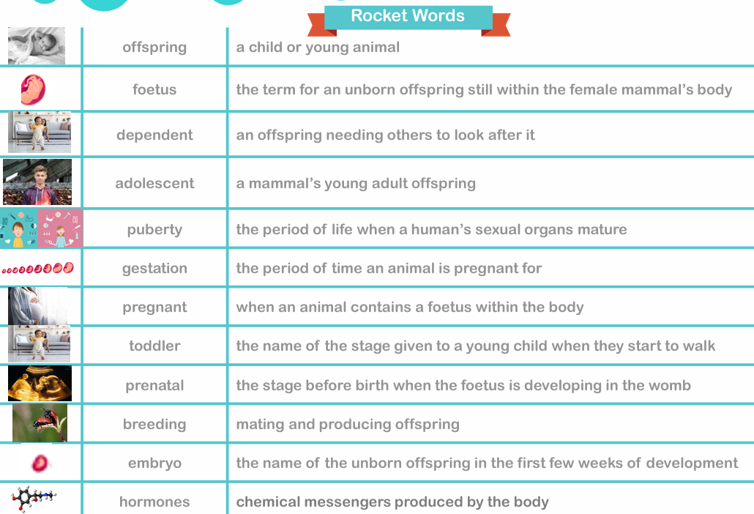
Key Rocket Words
History/Geography Learning
In Geography this half term, we will be exploring our local area by looking at maps, coordinates and grid references.
We will learn about map symbols and how to use grid references on ordinance survey maps. We will use this understanding to create our own maps and use these skills in fieldwork.
Science Learning
In Science this half term we will be exploring the unit ‘Animals, including humans.’ We will be able to describe the changes as humans develop to old age.
We will explore the human life cycle, including stages of development from birth to old age.
Spelling test Day
Key Days
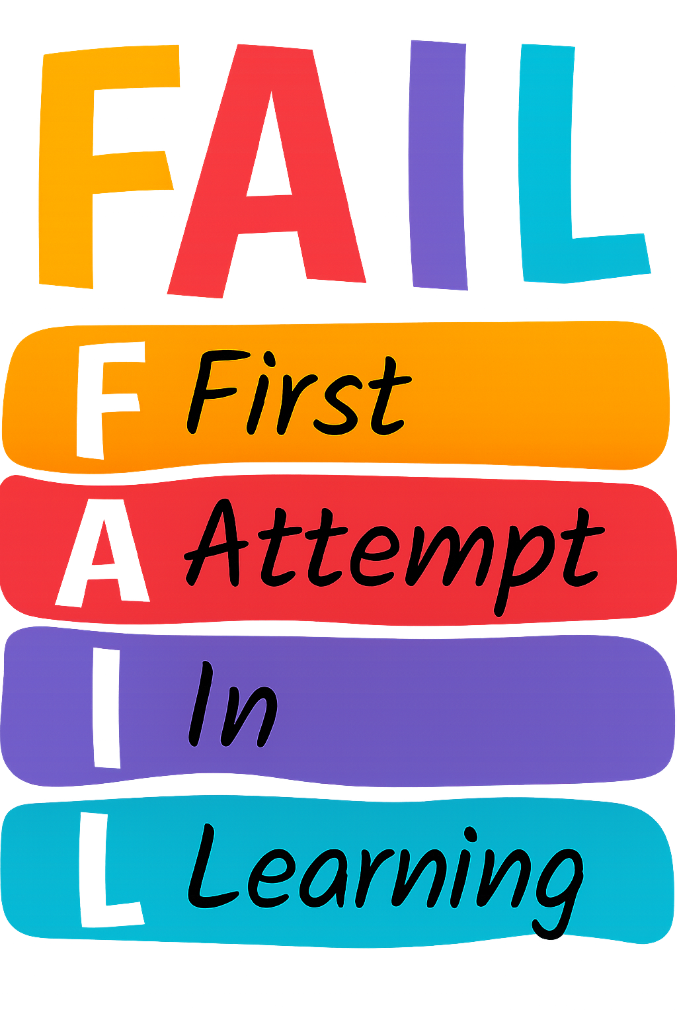

PE Day/s

- Friday
- Tuesday – swimming
- Friday - washlands

