
Nursery
Curriculum NEWSLETTER
LOGO
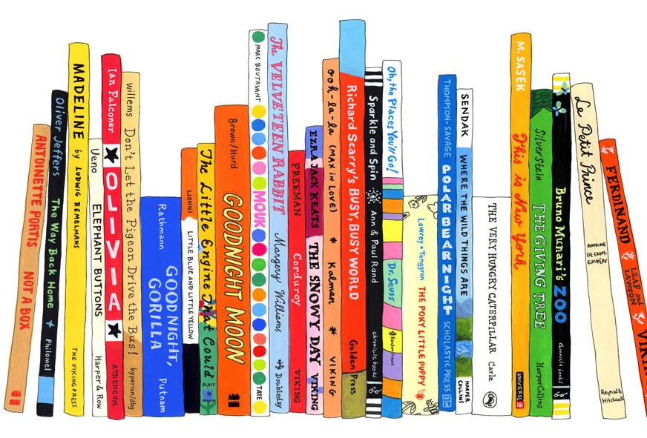
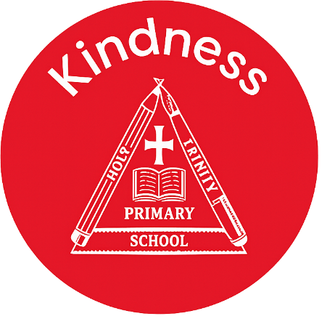

Maths Learning
We are looking at reading numbers within five, matching number to quantity and also shapes within the environment.

Welcome to this half-term in Nursery

Mrs Cartwright, Miss Pantall and Miss Gaunt are excited to begin a new topic.
Class teacher’s Message
English Learning
In phonics we are learning about rhythm and rhyming. We are using musical instruments to help the children begin to make simple rhythms, nursery rhymes to highlight rhyming words and phonics games.
We are learning about the traditional tales of The Three Little Pigs and then The Billy Goats Gruff.

“The more that you read, the more things you will know. The more that you learn, the more places you’ll go.”
– Dr. Seuss

INSIDE THIS NEWS
Body parts –
Can you help your child to use these words every day and point to them?
- Head
- Feet
- Arms
- Neck
- Toes
Key words
Reminders
Please remember to bring your child with a spare set of named clothes, a water bottle and also a bag each day.
We ask for a small weekly donation of £2 to help pay for extra curricular activities, cooking and crafts. This should be paid via parentmail. Thank you
- Inset Day – school closed Monday 26th January
- Moo Music – Friday 30th January
- Break up for February half term – Friday 13th February.
PSED Learning
The children will be continuing their learning using My Happy Mind. This program is helping to teach the children about feelings and emotions. It is also a great tool for the children to understand their brain and how to have a healthy mind and body.

Understanding the World Learning
We will be teaching the children about different animals, their habitats and also animals that are pets.

It’s important to fail in our learning!
Key Dates
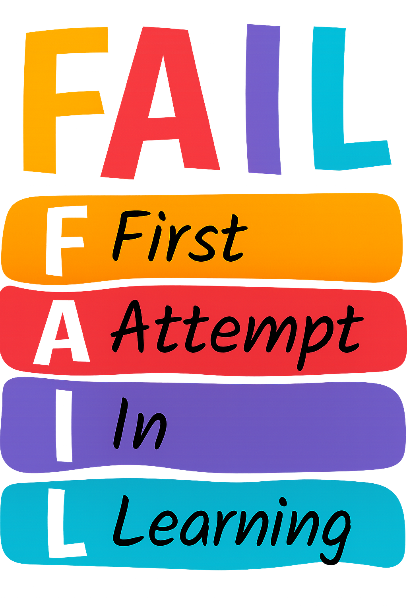

PE Day

- Wednesday morning

