
Nursery
Curriculum NEWSLETTER
LOGO
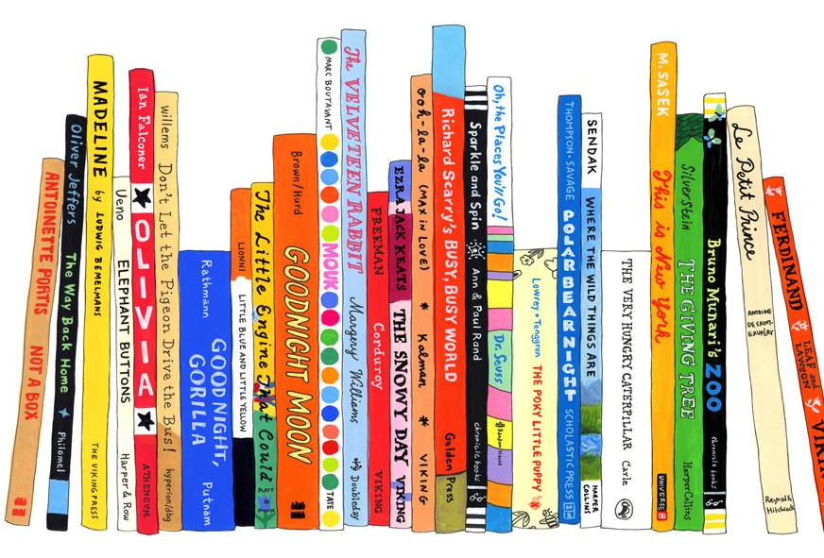
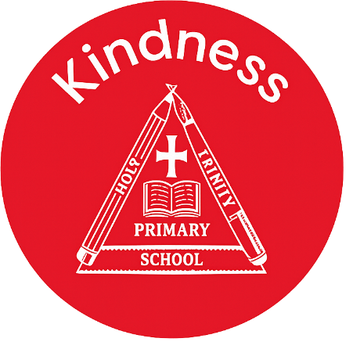

Maths Learning
We are looking at reading numbers within five, matching number to quantity and also shapes within the environment.

Welcome to this half-term in Nursery

Mrs Cartwright, Miss Pantall and Miss Gaunt are excited to begin a new topic!
Class teacher’s Message
English Learning
In phonics we are beginning to learn letter sounds, we will be doing this using our auditory skills. It is important that the children can begin to hear initial sounds in words, we do this through teaching a sound a week using objects of reference that match to those sounds.
Can your child tell you something that starts with S?

“The more that you read, the more things you will know. The more that you learn, the more places you’ll go.”
– Dr. Seuss

INSIDE THIS NEWS
Oral segmenting –
Can you help your child with their early oral segmenting skills. A good way to do this is during your usual routine. For example – Can you put on your c-oa-t, Can you stamp your f-ee-t?
PSED Learning
The children will be continuing their learning using My Happy Mind. This program is helping to teach the children about feelings and emotions. It is also a great tool for the children to understand their brain and how to have a healthy mind and body. We use the modules to teach during our Wellbeing Wednesday’s.

- World Book Day 5th March
- Three Little Pigs Theatre show 12th March
- Moo Music 13th March
- Stay and Play for new starters 23rd March
Key Dates
Key words
Reminders
Please remember to bring your child with a spare set of named clothes, a water bottle and also a bag each day.
We ask for a small weekly donation of £2 to help pay for extra curricular activities, cooking and crafts. This should be paid via parentmail. Thank you
Understanding the World Learning
We will be teaching the children about life cycles, we will look at the life cycle of a caterpillar and will be having our very own caterpillars to take care of and hopefully see them turn into butterflies!

It’s important to fail in our learning!
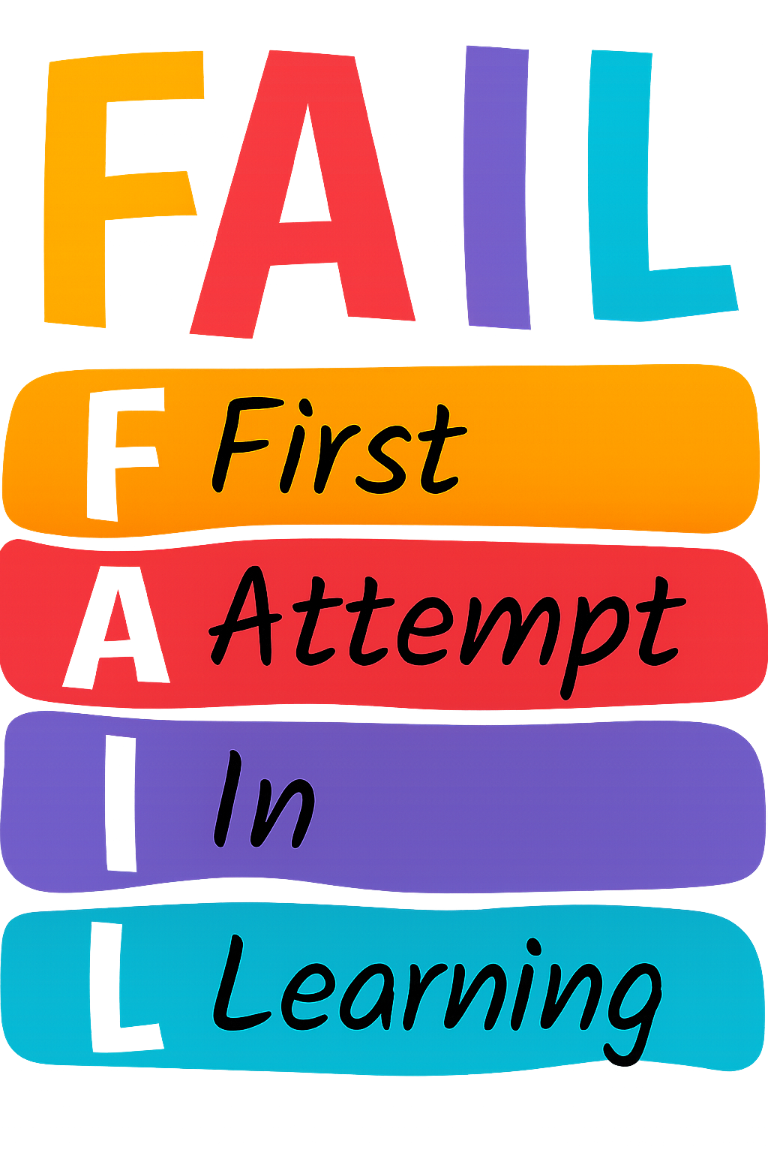

PE Day

- Wednesday morning

