
Nursery
Curriculum NEWSLETTER
LOGO

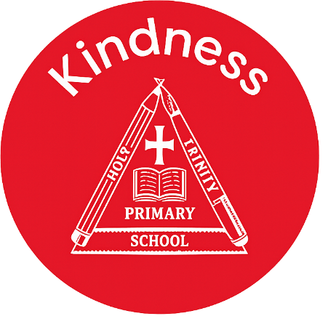

Maths Learning
We are working really hard to support the children with having consistent number recognition of numbers 1-5 then beyond to 10. Children should begin to match quantity to numeral independently.
We will be learning about capacity and prepositions.

English Learning
In phonics we are learning how to identify the initial sounds in words using our listening skills. We learn a new phoneme each week alongside a nursery rhyme. So far, we have learnt what objects begin with s,a,t,p,I,n,m,d – Can your child tell you anything that begins with these phonemes?
We are learning about Farms and then We’re going on a Bear Hunt. This story is great for supporting understanding of rhythm and rhyme.

Welcome to this half-term in Nursery

Mrs Cartwright, Miss Pantall and Miss Gaunt are excited to begin a new topic.
Class teacher’s Message
“The more that you read, the more things you will know. The more that you learn, the more places you’ll go.”
– Dr. Seuss

INSIDE THIS NEWS
Understanding the World Learning
We will be teaching the children about different how plants grow, we will be planting and caring for our very own sunflowers and also planting some vegetables, observing them over time to understand growth.

Blending – Can you practice blending these simple phonemes with your child? They should be able to blend the sounds together to tell you the word.
- d-u-ck
- d-o-g
- sh-ee-p
- h-e-n
- c-a-t
Key words
Reminders
Please remember to bring your child with a spare set of named clothes, a water bottle and also a bag each day.
We ask for a small weekly donation of £2 to help pay for extra curricular activities, cooking and crafts. This should be paid via parentmail. Thank you
- Inset Day – school closed Monday 26th January
- Moo Music – Friday 30th January
- Break up for February half term – Friday 13th February.
PSED Learning
The children will be continuing their learning using My Happy Mind. This program is helping to teach the children about feelings and emotions. It is also a great tool for the children to understand their brain and how to have a healthy mind and body.

It’s important to fail in our learning!
Key Dates
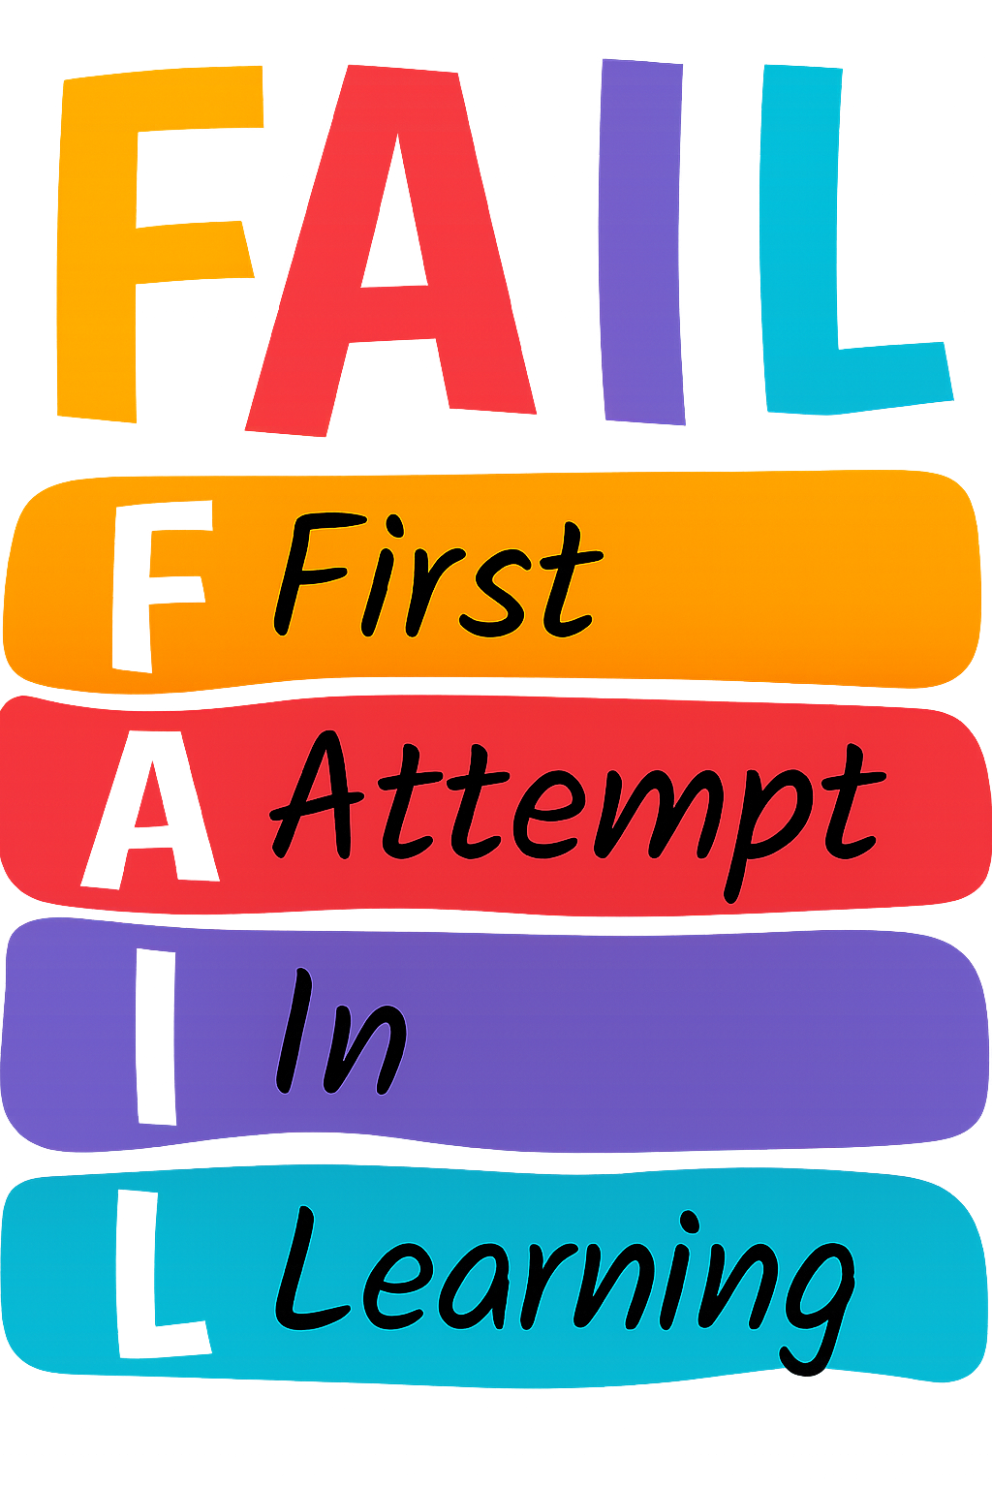

PE Day

- Wednesday morning

