
Nursery
Curriculum NEWSLETTER
LOGO
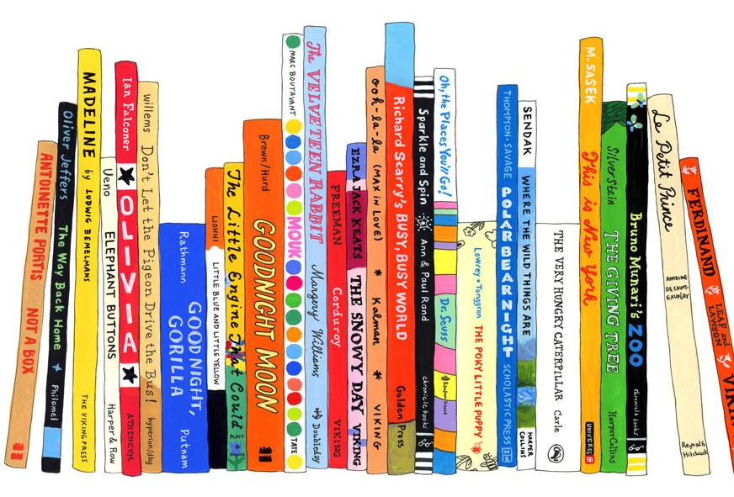
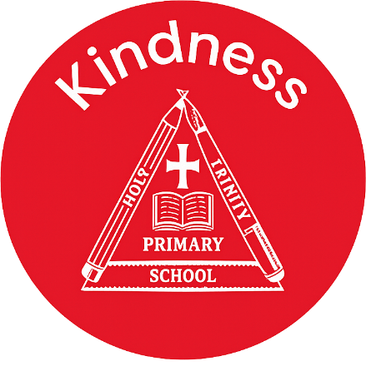

English Learning
In our Little Wandle phonics sessions we are learning a new rhyme each week. We are also learning letter sounds and how to orally blend sounds together to make words.
We are learning about under the sea. We will be taking part in world ocean day on the 8th June, as part of this topic we will be discussing how to look after our planet and recycling.
The children will be practicing how to write their name every day!

Welcome to this half-term in Nursery

Mrs Cartwright, Miss Pantall and Miss Gaunt are excited to begin a new topic of Under the Sea, Pirate and Princesses
Maths Learning
We are working really hard to support the children with having consistent number recognition of numbers 1-5 then beyond to 10. We will be comparing quantities understanding one more than as well as learning to count backwards!

Class teacher’s Message
“The more that you read, the more things you will know. The more that you learn, the more places you’ll go.”
– Dr. Seuss

INSIDE THIS NEWS
PSED Learning
The children will be continuing their learning using My Happy Mind. This program is helping to teach the children about feelings and emotions. It is also a great tool for the children to understand their brain and how to have a healthy mind and body.
We will be having a program of sessions run by the children’s mental health team, they will be discussing different feelings and moods using teddy bears.

Understanding the World Learning
We will be teaching the children about different how

Key Dates
- Friday 19th June – Moo Music
- Thursday 2nd July – Whole school transition morning
- Monday 13th July nursery stay and play
Blending – Can you practice blending these simple phonemes with your child? They should be able to blend the sounds together to tell you the word.
- F-i-sh
- S-ea
- T-a-p
- N-o-d
Syllables – Can you practice clapping the syllables in your name and your friends names?

Key words
Reminders
Please remember to bring your child with a spare set of named clothes, a water bottle and also a bag each day.
We ask for a small weekly donation of £2 to help pay for extra curricular activities, cooking and crafts. This should be paid via parentmail. Thank you

It’s important to fail in our learning!
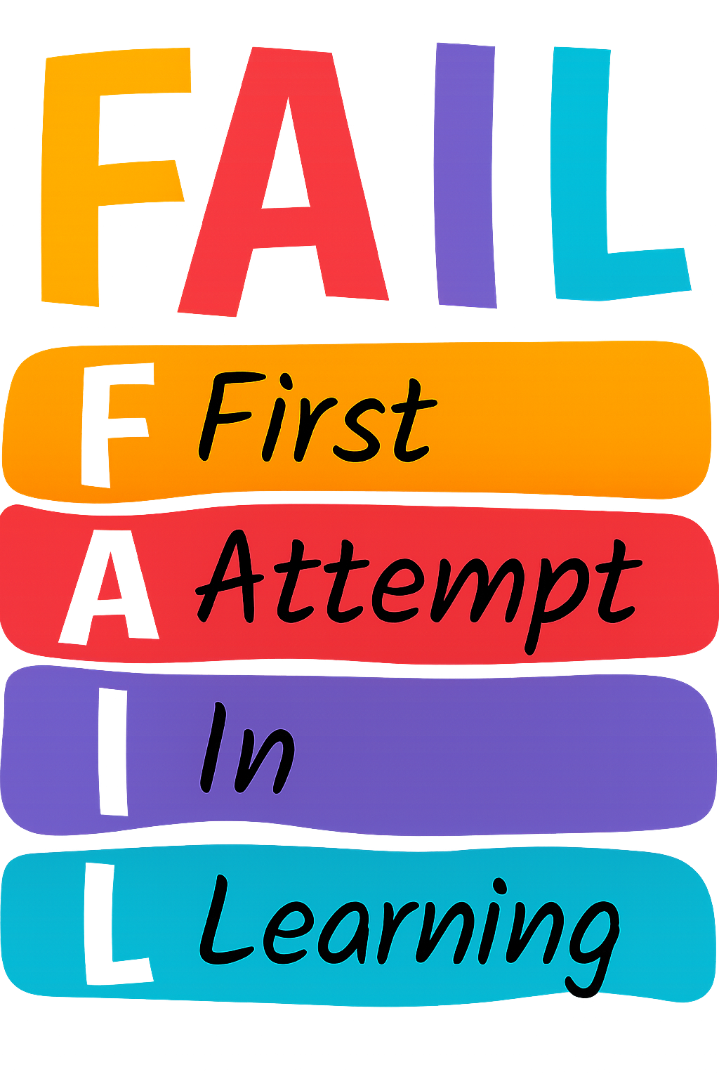

PE Day

- Monday morning

