
Year 6
Curriculum NEWSLETTER
LOGO
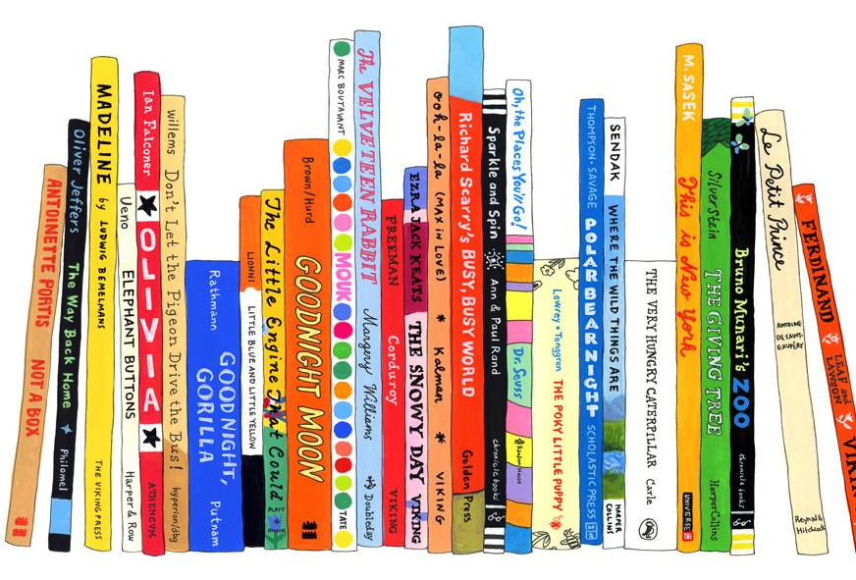
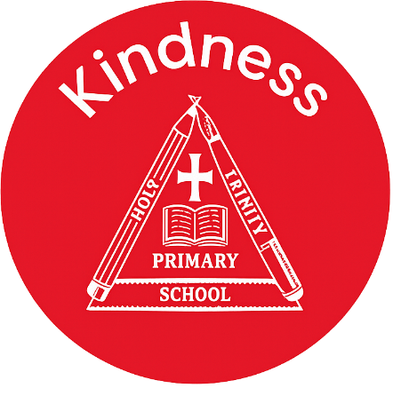
Class teacher’s Message
Maths Learning
In maths, we will be learning about fractions, decimals and percentages, applying our knowledge to multi-step word problems and SATs questions. We will also be completing an arithmetic starter every lesson, looking at key methods that we will need to use in preparation for our SATs.
English Learning
In English, we are focusing on writing stories and non-chronological reports. We will be looking at a range of grammar techniques, including using relative clauses, semi-colons to add detail and we will be learning how to use inverted commas correctly to add dialogue to our writing so that it advances the action.
In our reading lessons, we will be looking at the book, ‘Boy in the Tower’ by Polly Ho-Yen, continuing to develop our reading fluency and answering comprehension questions.
“The more that you read, the more things you will know. The more that you learn, the more places you’ll go.”
– Dr. Seuss

Welcome to this half-term in year

Teachers and adults working with the children

INSIDE THIS NEWS

Reminders
Remember to practise your times tables and practise those tricky arithmetic methods. Please ensure you are reading daily. Reading records need to be brought into school every day. .
It’s important to fail in our learning!
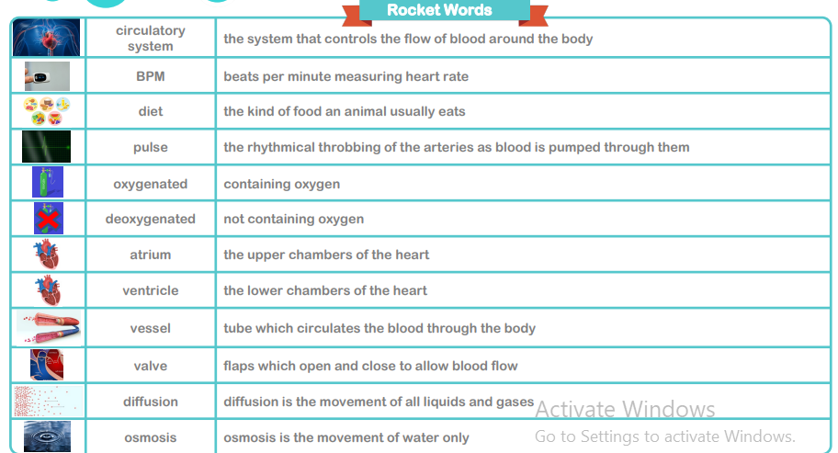
Key Rocket Words
Geography Learning – North America
In our Geography lessons, we will be exploring the physical and human features of North America. We will be building on our knowledge of earthquakes and studying a current geographical challenge – wildfires in California.

Science Learning – Animals, including humans
In our Science lessons, we will be learning to identify and name the main parts of the human circulatory system, describe the functions of the heart, blood vessels and blood and recognising the impact of diet, exercise, drugs and lifestyle on the way their bodies function. Finally, we will be describing the ways in which nutrients and water are transported within animals, including humans.
Spelling test Day
Key Days
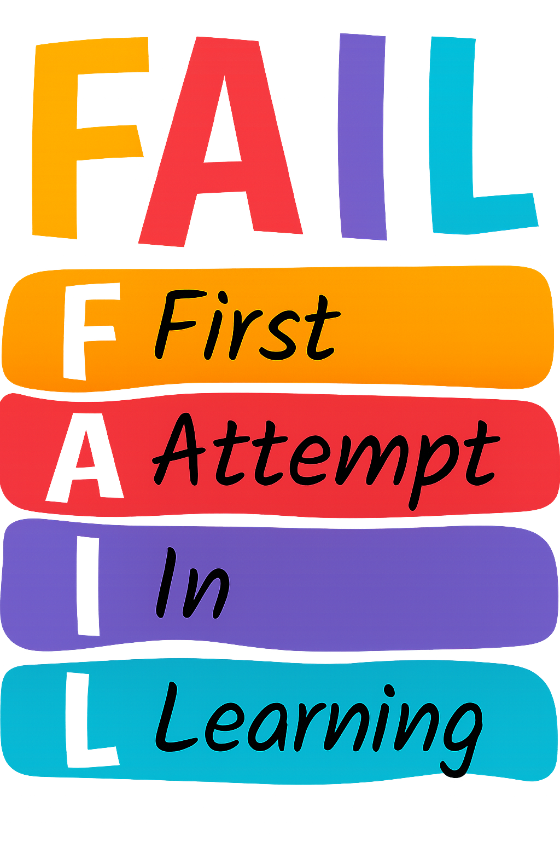

PE Day/s

- Every Friday.
- Every Tuesday – we are going to the Warehouse for our PE lessons. :)

