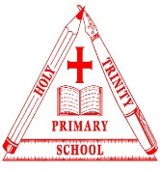
Holy Trinity C.E. (C) Primary School
Religious Education Policy
Introduction

Religious education (RE) provides the opportunity for pupils to reflect upon the world around them, to raise questions about the ultimate meaning and purpose of life and to consider what it means to be human. It plays an important role in defining the school’s distinctive Christian character. The SIAMS schedule 2018 (Strand 7) makes it clear that RE should reflect the school’s Christian vision. The subject is regarded as a core subject within the school’s curriculum. It has a vital role in developing religious literacy and deepening pupils’ understanding of Christianity, in all its forms, and fostering appreciation and understanding of other faith traditions. Through knowledge, religious education enables pupils to develop respect for and sensitivity to others, in particular those whose faiths and beliefs are different from their own. RE is non-confessional and should be treated as an academic subject in its own right.

As the Church of England document, ‘Making a difference? A review of Religious Education in Church of England schools 2014’ recommends that the RE curriculum in all schools should,
“…….ensure it provides a more coherent, progressive and challenging approach to the teaching of Christianity within the context of the wider exploration of the diversity of religion and belief in the modern world”
“……explore ways of extending pupils’ ability to think theologically and engage in theological enquiry as part of their learning in RE”

[Signature] |  | [Signature]
Richard Winterton  Chair of Governors |  | Nicola Oliphant  Headteacher
Date |  | Date

RE Statement of Entitlement

RE teaching at this school will be in line with the recommendations of the Statement of Entitlement for Church Schools, published by the Church of England Education Office (Feb 2019), see link below:

http://smartfile.s3.amazonaws.com/d57a4d93b010f2ac6f24bc8cee2d789e/uploads/2019/02/NEW-RE-Statement-of-Entitlement-for-Church-schools.pdf

Christianity will, therefore, be at least 50% of RE curriculum time. The teaching of Christianity is core to the teaching of RE in this Church of England school. However, as a Church school we have a duty to foster an accurate and increasing understanding of world religions and worldviews. As a result, pupils will gain greater insight into the world in which they are growing up. They will also learn to appreciate the faith of others and develop a deeper understanding of their own ideas and beliefs. These outcomes must contribute to harmonious relationships within and between communities, promoting social inclusion and combating prejudice and discrimination.

Statutory Requirements and the RE curriculum

RE teaching also follows the legal requirements of the Education Reform Act (1988), which places RE as part of the basic curriculum; a statutory subject which is an entitlement for all pupils.

The school bases its RE provision on the Staffordshire Locally Agreed Syllabus. In addition, the school uses the Lichfield Diocesan RE guidelines, Understanding Christianity resources and other appropriate materials to enhance teaching and learning.

At least 5% (closer to 10%) of curriculum time will be dedicated to meeting explicitly RE objectives, although the subject may be taught across the curriculum when appropriate. Within this teaching allocation at least 50% of subject content will be allocated to an exploration of the Christian faith, and the concepts, beliefs, teachings and practices that lie at its heart.

The aims of RE within the Staffordshire Agreed Syllabus and central to the process of learning in Religious education are that pupils should acquire:

- Exploring: An increasing core of insightful knowledge concerning the religions and beliefs, both in Britain and in more global terms;
By exploring religious beliefs, teaching and practices.
- Engaging: A developing capacity to engage with ultimate questions and to formulate their own sense of identity and values; By engaging with fundamental questions.
- Reflecting: A growing range of the social, spiritual and emotional skills and dispositions appropriate to living well in a religiously plural and open society; By reflecting on the reality of religious diversity and on the issues raised by living in a diverse world.

The aims of Religious Education in our school are:
- To help pupils to know about and understand Christianity as a living world faith through the exploration of core theological concepts using an approach that critically engages with text.
- To help and provide opportunities for pupils to consider the impact and connection that Christianity has on Britain’s cultural heritage and the lives of people worldwide
- To enable all pupils to develop knowledge and understanding of other major world religions and world views and their impact on society and culture.
- To give pupils a safe space and to provide opportunities to critically reflect on their own religious, spiritual and/or philosophical convictions.
- To help pupils to develop knowledge and skills in making sense of religious texts and teachings and understanding their impact on the lives of believers.
- To develop pupils’ abilities to connect, critically reflect upon, evaluate and apply their learning to their own growing understanding of religion and belief, of themselves, the world and human experience.
- To develop an understanding of religious faith as the search for and expression of truth, and so to consider important human questions, values and concerns; to be curious and inquisitive about life; not afraid to ask the big questions.
- To nurture understanding, respect and open-mindedness and inspire lifelong engagement with the study of religions and beliefs.

As a church school the following aims are also important:

- To explore the Bible as the foundation document of Christianity, especially the life, teaching and significance of Jesus Christ and the early Christian community.
- To enable children to engage with Christian concepts and beliefs concerning God, the world and humanity.
- To assist and to encourage young people to experience Christian life and worship, including the use of the church’s year and links with the local Christian community.

The outcomes for pupils at the end of their time in our school are that they are able to:

- Compare and contrast key beliefs and practices of the religions studied and show how they are connected to believers’ lives.
- Describe different aspects of belonging to a religion – symbol, story, festival, belief, faith in action, ritual, worship.
- Express religious beliefs and ideas with the appropriate language, vocabulary and terminology and describe what they mean.
- Ask questions sensitively about the lives of believers and suggest appropriate answers.
- Reflect on the decisions people make – including believers – and suggest possible outcomes.
- Compare their own experience and identity with others – including believers.
- Reflect and empathise with the big questions of life, suggesting some answers/insights
- Be confident to explore their own spirituality and search for truth
- Value the religious journey of faith
- Develop pupils’ ability to interpret and appreciate religious imagery and expression.

Spiritual, moral, social and cultural development (SMSC)

In addition, the subject contributes to other areas of education and human experience and plays an important part of the wider programme of spiritual, moral, social and cultural (SMSC) development.
Spiritual | Widening pupils’ vision of themselves and their own experience, within the context of a growing awareness and understanding of God.
Moral | Helping each pupil develop their own informed values.
Social | Helping pupils understand some major forces shaping the values of our society.
Cultural | Aiding pupils in exploring aspects of their own cultural heritage, and developing positive attitudes towards diversity.

As a church school it is important to think about how the RE policy will fit into the overall ethos of our school – it is obviously not the only way the ethos is communicated, but does play an important part.

Additional links will be found across the curriculum especially with personal, social, health and citizenship education (PSHCE), Relationship and Sex Education (RSE) and British values. RE can also make a positive contribution to enhancing creativity and enjoyment and ensure the well-being of pupils.

A Golden Threads document has been made to show the progression of skills and learning within RE from EYFS to Year 6. This is underpinned by the big questions that are asked within each topic.
See RE Golden Threads document for more information.

School values and RE practice

These link closely with our whole school values and motto:


Our school motto is “Aspire to be more, not to have more.” This is shown through the account of the Widow’s mite in the Bible (Mark 12: 41—44) Jesus sees a woman who gives a few coins to the temple collection. The material value is small but Jesus notes her contribution. This woman is not named. She is poor and overlooked by most. Her actions show that she is trying to be the best that she can be and she is willing to give all that she has in this. This is our aim.

Our values are:
1. Koinonia
2. Love
3. Honesty
4. Forgiveness
5. Dedication
6. Courage

Each half term sees us focusing on embedding each value and a bible story to link to these.
- Koinonia, a Greek word meaning ‘belonging to a community’ is used to welcome in the new academic year and the new children joining the Holy Trinity family. We learn about The parable of the Lost Sheep to support this value.
- Love – This value was chosen on the lead up to the Christmas season to support and cherish the love God gives us with the birth and arrival of his son. We learn about Psalm 23 to support this value.
- Honesty - To start every New Year we believe in honesty about the beginning we are about to have and how we will behave and treat others over the coming year. We learn about Zacchaeus the Tax Collector to support this value.
- Forgiveness - As a school, we believe that one of the most important Christian values is forgiveness. We focus on forgiving during the run up to Easter, when we are thinking about the sacrifices Jesus made for us. We learn about the restoration of Peter to support this value.
- Dedication - During the summer we wish the children to show their determination and dedication to themselves and their lifelong learning during their ‘testing times’. We learn about ‘Running the race – Hebrews 12: 1-3’ to support this value.
- Courage - We all need courage at the end of the academic year to help support us to face whatever new adventures September may bring us, whether it be a new classroom and teacher or a move to a new school. We learn about Daniel and the Lion’s Den to support this value.
Our school values are interlinked with our Collective Worship schedule and our broader curriculum. To further embed our school values, each value is linked to a bible story and genre, to support and deepen the children’s understanding in how fundamental these values are to our approach to all areas of school life (see Appendix 1 and 2). This is shown through the children’s learning, our teaching, the way we assess, everyone’s behaviour to how all members of our community model this throughout our school and in the wider community.
The management of RE

RE is given equal status with other core subjects in staffing, responsibility and resourcing. Pupil achievement in RE should equal or be better than comparable subjects. Teachers should share effective practice locally and regionally and engage in professional development (SIAMS 2018).

As a church school we recognise that it should be a priority to build up staff expertise in RE.

The RE Subject Leader, supported by the Headteacher, is responsible for improving the standards of teaching and learning in Religious Education through:
- Producing a scheme of work for the school
- Supporting colleagues in the detailed planning and delivery of RE provision
- Ensuring Religious Education has status within the school
- Keeping in touch with subject developments and disseminating information as appropriate
- Auditing and recording current resources, supplementing resource provision when money is available and disseminating this information to staff
- Undertaking personal development and subject training and ensuring provision for staff INSET
- Monitoring RE provision, practice and outcomes – e.g. through book scrutines, pupil voice, assessment.
- Ensuring rigorous systems of assessment are in place (SIAMS 2018) and are in line with the Local Agreed Syllabus
- Creating the RE Action plan and ensuring its regular review
- Accountability for RE standards in the school
- Meet with member of the Diocesan RE advisory team when possible.

Planning

Units of work should be planned to develop the three curriculum aims and to allow for regular review of pupils’ progress.

This would normally, but not exclusively, mean that pupils should be guided through the curriculum aims as follows:
- Exploring the issue or dimension, encountering the context, following up questions and establishing new knowledge concerning religion and belief (Exploring)
- Investigating the impact of beliefs and practices on lifestyles, attitudes and action and considering the ways in which beliefs, spiritual insights and ideas are expressed, engaging with fundamental questions to understand why people respond to life as they do (Engaging)
- Reflecting on diversity within the dimension, and on personal responses to this diversity to develop their own standpoints and self-understanding (Reflecting).

The three curriculum aims are supported by six broad dimensions:
- Beliefs, teachings and sources.
- Practices and ways of life
- Expressing meaning
- Identity, diversity and belonging
- Meaning, purpose and truth
- Values and commitments.

RE outcomes for pupils

Children from Years 1 to 6 should have a weekly Religious Education lesson.

Content will directly reflect the requirements of the Staffordshire Agreed Syllabus and that of the Lichfield Diocese i.e. Christian material will predominate followed by the two other faiths of Islam and Hinduism. At Key Stage One we will focus on Christianity and Islam. At Key Stage Two we will focus on Christianity, Islam and Hinduism. Other faiths will also be referred to where appropriate to RE topics or themes. Materials from ‘Understanding Christianity’ are used throughout the year groups to link to the Staffordshire Agreed Syllabus and the ‘big question’ each class focuses on per half term, to enhance teaching and learning.

Our assessment framework takes the form of age related expectations, which supports and promotes the development of the above aims, which identify a religious literate person and is consistent with those used in other subject areas.

See Appendix 3 for an example of an overview for a half term plan.

Children should have opportunities, as appropriate, to:
- Encounter people from different religious and philosophical groups who can express a range of convictions on religious and moral issues.
- Visit places of religious significance.
- Use ICT to enhance understanding.
- Discuss, question and evaluate important issues in religion and philosophy including ultimate questions and ethical issues.
- Reflect upon and carefully evaluate their own and others’ beliefs and values using reasoned and balanced arguments.
- Use a range of forms of expression to communicate their arguments.
- Explore the connection between RE and other curriculum areas.

Inclusion

Religious Education offers the opportunity to draw on other subject areas from across the curriculum. This allows children the opportunity to access the subject through a range of formats. Units of work are planned to ensure there are no barriers to every pupil achieving, which will mean that in many cases, pupils will be able to study fully the requirements of the locally agreed syllabus.

Right to withdrawal

At Holy Trinity Primary School, we wish to be an inclusive community but recognise that parents have the legal right to withdraw their children from religious education or collective worship on the grounds of conscience, without giving a reason. Parents wishing to exercise this right are asked to write to the headteacher, who will then invite the parents into school and set out the options open to the parents as set out in education law. However, the right of withdrawal does not extend to other areas of the curriculum when, as may happen on occasion, spontaneous questions on religious matters are raised by pupils or there are issues related to religion that arise in other subjects. Where a pupil is withdrawn from RE and do not take part in alternative religious education, they will be supervised by an appropriate member of staff whilst doing work set by their parents which will seek to further their knowledge and understanding of their parents’ beliefs and values.

The Governing Board

Regular reports are made to the governors on the progress of Religious Education provision and to our Religious Education Link Governor.
This policy will be reviewed every three years to ensure relevance, effectiveness and practicality, or in the light of changes to legal requirements.

This policy is in line with other school polices and therefore should be read in conjunction with the following school policies:

Teaching and Learning Policy;
Assessment and Record Keeping;
Responding to pupils’ work / Feedback / Marking policy;
Special Educational Needs Policy;
Computing Policy;
Equal Opportunities Policy;
Spirituality Policy;
Health and Safety Policy.

Reviewed by: R. Steele, Summer 2024
Next review date: Summer 2026

Appendix 1 – Motto and values
Aspire to be more,  not to have more | The Widow’s Offering  Genre – Jesus’ teaching | Mark 12: 41 -44
 | Parable of the lost sheep  Genre – moral story that Jesus told | Luke 15: 3-7
Love | The 23rd Psalm  Genre – poetry about the good shepherd (Jesus) | Psalm 23: 1 - 6
Honesty | New testament: Zacchaeus  Genre – recount of the amazing change when a tax collector meets Jesus | Luke 19: 1 - 10
Forgiveness | The risen Jesus meets with Peter and restores him  Genre – biography | John 21: 1 - 25
Dedication | Running the race  Genre – letter from Paul to the Hebrews | Hebrews 12: 1 – 3
Courage | Old Testament: Daniel and the lion’s den  Genre – historical | Daniel 6: 1 - 23
Appendix 2 – Example of newsletter
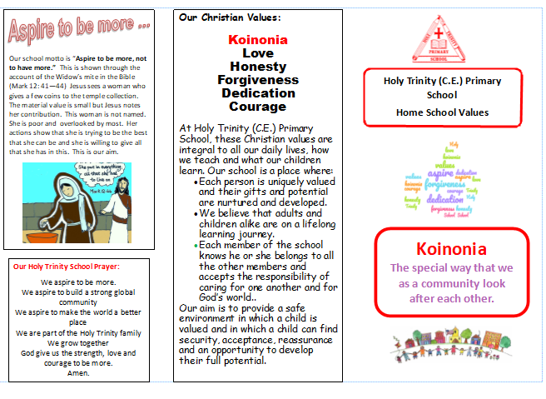

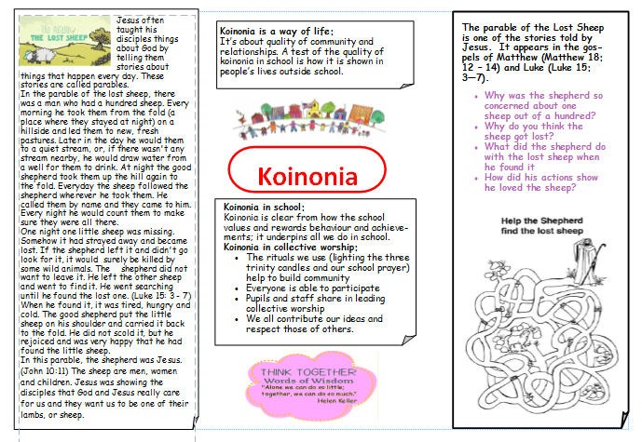

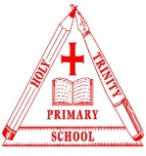
Appendix 3 Holy Trinity CE (C) Primary School Planning Overview
Topic: 1.3b Worship and ceremonies Class: 3 and 4 Term & Year: Spring 1 2022
What is the key question?  Why are actions, gestures and rituals important in worship and ceremonies? | What difference does this make to the lives of believers? (church)  .  - Which different actions, gestures and rituals can be identified?  - Why are symbolic gestures, actions and rituals important?  - How are symbolic gestures, actions and rituals used as part of worship and ceremonies?
What is/are our main learning objective(s)?

- EXPLORE: To identify actions, gestures and rituals used as part of worship and ceremonies and why they might be important to believers.
- ENGAGE: To link actions, gestures and rituals to faith stories and belief.
- REFLECT: To identify actions, gestures or rituals from their own experience and suggest how this might express what is important to them.
What are the key concepts? Are there links to others? Links to other faiths?  - To identify actions, gestures and rituals used as part of worship and ceremonies and say how they might be used.  - To suggest why these actions might be important to believers. | So what? What can we explore/learn? How is it relevant to us?  - Explore others’ beliefs.  - Explore different religious worship and ceremonies.  - Explore and recognise different actions and rituals in worship and ceremonies.  - Empathising by considering the attitudes, beliefs and values of others and why these actions are important.  - Evaluate the different ways people worship and link to own experiences.
How do we initially engage them?
- Show the children different items linked to Christmas. What signs are there in the local area normally that Christmas is arriving? Why do they think that Christmas matters to Christians?
How do we link it into the narrative?  - Psalm 18:2 – God is my rock  - John 8 :12 – Jesus is the light of the world  - Psalm 23 – Lord is my shepherd. | How do we know if they have achieved the objectives? (Assessment)  At age related:  - Children will be able to identify actions, gestures and rituals used as part of worship and ceremonies and how they are used.  - Children will be able to say how these actions, gestures and rituals might be used and why they might be important to believers.  Greater Depth:  - Children will be able to use and discuss this knowledge of symbolic actions, gestures and rituals and link with their own experiences to show why they may be important in different worship and ceremonies.

