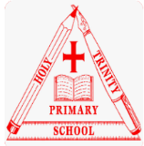
Holy Trinity CE (c) Primary School
Protected Characteristics throughout the curriculum

At Holy Trinity, we actively promote learning about the protected characteristics in our curriculum and embed these within our vision and values for school. We take part in different themed days and weeks throughout the year, such as Diversity Week and Children’s Mental Health Week, to ensure all children are aware of our protected characteristics and to embed our inclusive curriculum. We also ensure we discuss our protected characteristics when taking part in our ‘What’s in the news?’ sessions and completing our Reflection journals for this. Alongside the modules listed below, children learn about having mutual respect for others and discuss the protected characteristics through RE units, reading books that are carefully chosen for the children to use and historical and influential figures to ensure an inclusive curriculum.

Characteristic | Taught within
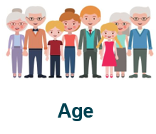 | EYFS – Life cycles – Children discuss different life cycles of animals and how they grow.  Year 1 – PSHE – Happy and healthy me – Children learn about the changes that take place since they were born and how they might change in the future.  Year 2 – Science – Animals, including humans – Children notice that animals, including humans, have offspring which grow into adults.  Year 4 – PSHE – Happy and healthy me – Children learn about what is meant by a life cycle and discuss the changes that take place during puberty as the body changes from a child into an adult. They discuss how changes are a natural part of growing up and that change is a gradual process.  Year 4 – PSHE – Happy and healthy me – Children recognise and understand how they emotions change as they grow up. They explain that feeling change during puberty and how feelings and actions have an impact on others.  Year 5 – PSHE – Happy and healthy me – Children learn about puberty and how it is a time when they grow from a child into an adult, including physical and emotional changes.  Year 5 – Animals, including humans – Children describe the changes as humans develop to old age.  Year 6 – Living things and their habitats – Children describe the differences in the life cycles of a mammal, an amphibian, an insect and a bird. They also describe the life process of reproduction in some plants and animals.  Year 6 – PSHE – Happy and healthy me – Children consolidate their learning about the physical and emotional changes they go through during puberty.  Year 6 – PSHE – Me and my relationships – Children will learn about the skills and strategies needed as they approach puberty and the changes that take place, identifying ways of coping with growing up.  Year 6 – PSHE – Me and other people – Children recognise and challenge stereotyping, using the protected characteristics.
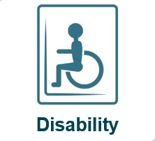 | EYFS – Children learn about their own and different family units.  Year 1 – PSHE – Me and my relationships – Children learn about different types of family units.  Year 2 – PSHE – Me and other people – Children learn about different types of family units.  Year 3 – PSHE – Me and my relationships – The children recognise that families come in many different forms and explain why children might be in different family arrangements.  Year 4 – Me and other people – Children learn about the range of people who are in Britain today, discussing respecting everyone.  Year 5 – PSHE – Me and my relationships – Children learn about different types of family and explain why it is important to show respect for differences.  Year 6 – PSHE – Me and other people – Children recognise and challenge stereotyping, using the protected characteristics.
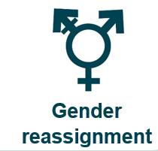 | EYFS – Children learn about their own and different family units  Year 1 – PSHE – Me and my relationships – Children learn about different types of family units.  Year 2 – PSHE – Me and other people – Children learn about different types of family units. Using the Stonewall ‘different families, same love’ resources. They also use the Expect Respect toolkit to question assumptions and challenge stereotypes about what boys and girls can do.  Year 3 – PSHE – Me and my relationships – The children recognise that families come in many different forms and explain why children might be in different family arrangements.  Year 4 – Me and other people – Children learn about the range of people who are in Britain today, discussing respecting everyone.  Year 5 – PSHE – Me and my relationships - Children recognise and challenge gender stereotyping. They learn about different types of family and explain why it is important to show respect for differences.  Year 6 – PSHE – Me and my relationships – Children look at the attitudes and beliefs held by some people about the roles played by men and women in society and have an opportunity to challenge gender stereotypes.  Year 6 – PSHE – Me and other people – Children recognise and challenge stereotyping, using the protected characteristics.  Themed weeks – Diversity week, Anti-Bullying week
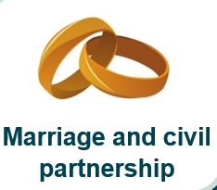 | EYFS – Children learn about their own and different family units. They learn about weddings in their RE units and other celebrations.  Year 1 – PSHE – Me and my relationships – Children learn about different types of family units.  Year 2 – PSHE – Me and other people – Children learn about different types of family units.  Year 3 – PSHE – Me and my relationships – The children recognise that families come in many different forms and explain why children might be in different family arrangements.  Year 4 – Me and other people – Children learn about the range of people who are in Britain today, discussing respecting everyone.  Year 5 – PSHE – Me and my relationships – Children learn about why some people choose to marry and others do not. They learn about different types of family and explain why it is important to show respect for differences.  Year 6 – PSHE – Me and other people – Children recognise and challenge stereotyping, using the protected characteristics.
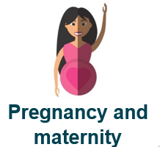 | Year 1 – PSHE – Happy and healthy me – children learn about the changes that take place since they were born and how they might change in the future.  Year 2 – PSHE – Me and other people – Children learn about different types of family units. Using the Stonewall ‘different families, same love’ resources.  Year 3 – PSHE – Me and my relationships – The children recognise that families come in many different forms and explain why children might be in different family arrangements.  Year 4 – Me and other people – Children learn about the range of people who are in Britain today, discussing respecting everyone.  Year 5 – PSHE – Me and my relationships – Children learn about different types of family and explain why it is important to show respect for differences.  Year 5 – Science – Animals, including humans – Children learn about different gestation periods of animals, comparing these with humans.  Year 6 – PSHE – Happy and healthy me – Children learn some basic facts about pregnancy and conception.  Year 6 – PSHE – Me and other people – Children recognise and challenge stereotyping, using the protected characteristics.  Year 6 – Living things and their habitats – Children describe the differences in the life cycles of a mammal, an amphibian, an insect and a bird. They also describe the life process of reproduction in some plants and animals.
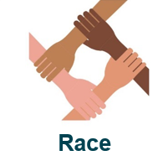 | EYFS – Children learn about their own and different family units.  Year 1 – PSHE – Me and my relationships – Children discuss groups we belong to and begin to have an understanding and appreciation of the range of different cultures within school.  Year 1 – History – Children learn about the role Mary Seacole had and why it is important to remember what she and Florence Nightingale did for others, discussing injustice at how Mary Seacole was treated.  Year 1 – PSHE – Me and other people – Children develop an understanding and appreciation of the range of different cultures within school and their community. They also look at the Expect Respect toolkit as part of this.  Year 2 – PSHE – Me and other people – Children learn about similarities between people of different races in the UK and understand that Britain is a diverse place.  Year 2 – History - How have Rosa Parks and Nelson Mandela helped make the world a better place? Children will discuss respect and how it is wrong to discriminate against others.  Year 3 – PSHE – Me and my relationships – The children recognise that families come in many different forms and explain why children might be in different family arrangements.  Year 3 – PSHE – Me and other people – The children learn about how to identify similarities and differences between local communities, including discussing religion, race, nationality and ethnicity. They recognise the range of identities in our wider community today. The ‘difference and diversity’ curriculum is used to explore this further.  Year 4 – PSHE – Me and other people – Children learn about how to appreciate the range of national, regional, religious and ethnic identities and discuss respecting equality and being a productive member of a diverse community.  Year 4 – PSHE – Me in the world – Children will learn about what rights and responsibilities are and describe how people campaign for their rights and those of other people.  Year 5 – PSHE – Me and my relationships – Children learn about different types of family and explain why it is important to show respect for differences.  Year 5 – PSHE – Me and other people – Children learn to reflect on other people’s experiences and appreciate a range of national, regional, religious, ethnic identities in the UK.  Year 6 – PSHE – Me in the world – Children develop their interest in exploring, improving understanding of and showing respect for different faiths and cultural diversity, through looking at the role of voluntary, community and pressure groups.  Year 6 – PSHE – Me and my relationships – Children discuss attitudes and beliefs held by some people about race in society and think about the consequences of racial bullying, discussing how it is important to respect everyone and not to discriminate due to race.  Year 6 – PSHE – Me and other people – Children recognise and challenge stereotyping, using the protected characteristics.  Themed weeks – Diversity week, Anti-bullying week, Black History Month
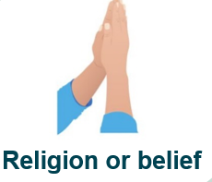 | EYFS – Celebrations – Children discuss the similarities and differences between their peers and different celebrations that their peers may have.  Year 1 – PSHE – Me and my relationships – Children discuss groups we belong to and begin to have an understanding and appreciation of the range of different cultures within school.  Year 1 – PSHE – Me and other people – Children develop an understanding and appreciation of the range of different cultures within school and their community. They also look at the Expect Respect toolkit as part of this.  Year 2 – PSHE – Me and other people – Children learn about different types of family units and discuss why it is important to show mutual respect.  Year 3 – PSHE – Me and my relationships – The children recognise that families come in many different forms and explain why children might be in different family arrangements.  Year 4 – PSHE – Me and other people – Children learn about how to appreciate the range of national, regional, religious and ethnic identities and discuss respecting equality and being a productive member of a diverse community.  Year 4 – PSHE – Me in the world – Children will learn about what rights and responsibilities are and describe how people campaign for their rights and those of other people.  Year 5 – PSHE – Me and my relationships – Children learn about different types of family and explain why it is important to show respect for differences.  Year 5 – PSHE – Me and other people – Children learn to reflect on other people’s experiences and appreciate a range of national, regional, religious, ethnic identities in the UK.  Year 6 – PSHE – Me in the world – Children develop their interest in exploring, improving understanding of and showing respect for different faiths and cultural diversity, through looking at the role of voluntary, community and pressure groups.  Year 6 – PSHE – Me and other people – Children recognise and challenge stereotyping, using the protected characteristics.  Themed weeks – Diversity week, Anti-bullying week, Values days, Faith Trail
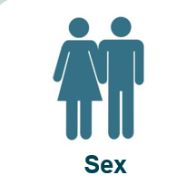 | Year 1 – PSHE – Me and other people – Children learn about the similarities and differences between them and others and discuss what makes them special.  Year 2 – PSHE – Happy and healthy me - This links to the National Curriculum for Science in Year 2. The children name boy’s and girl’s body parts and describe the differences.  Year 2 – PSHE – Me and other people – Children learn about the similarities and differences between girls and boys.  Year 3 – PSHE – Happy and healthy me – Children learn about how to identify the differences between males and females, whilst challenging gender stereotypes. They name the main internal and external parts of the body.  Year 5 – PSHE – Happy and healthy me – Children learn about which changes happen to both boys and girls during puberty.  Year 6 – PSHE – Happy and healthy me – Children become more familiar with the internal organs and their functions in the body of the male and female.  Year 6 – PSHE – Me and my relationships – Children look at the attitudes and beliefs held by some people about the roles played by men and women in society and have an opportunity to challenge gender stereotypes.  Year 6 – PSHE – Me and other people – Children recognise and challenge stereotyping, using the protected characteristics.
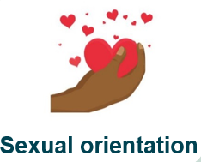 | EYFS – Children learn about their own and different family units  Year 1 – PSHE – Me and my relationships – Children learn about different types of family units.  Year 2 – PSHE – Me and other people – Children learn about different types of family units using Stonewall resources for ‘different families, same love’.  Year 3 – PSHE – Me and my relationships – The children recognise that families come in many different forms and explain why children might be in different family arrangements.  Year 5 – PSHE – Me and my relationships – Children learn about different types of family and explain why it is important to show respect for differences.  Year 4 – Me and other people – Children learn about the range of people who are in Britain today, discussing respecting everyone.  Year 6 – PSHE – Me and other people – Children recognise and challenge stereotyping, using the protected characteristics.  Themed weeks – Diversity week, Anti-bullying week.

