
Tuesday 29th April 2025

Dear Parent/Carer,

Our school is part of Operation Encompass which is a national scheme that operates jointly between schools and police forces.

Operation Encompass is the reporting to schools, prior to the start of the next school day, when a child or young person has experienced domestic abuse.

As a school we have ensured that a member of our staff, (Mrs Nicola Oliphant, Headteacher and Designated Safeguarding Lead DSL), has been trained in the Operation Encompass procedures allowing us to then use the information that has been shared, in confidence, to support the child/ren in our care.

The Domestic Abuse Act 2021 identifies children who experience domestic abuse as victims of domestic abuse in their own right.

On 24 May 2024 Royal Assent was granted to The Victims and Prisoners Act. The Act placed Operation Encompass into Law. This places a statutory obligation on police forces to share Operation Encompass notifications with schools and/or educational settings.

We are keen to offer the best support possible to all our pupils and through Operation Encompass we will be able to provide the best possible support to our children.

Yours
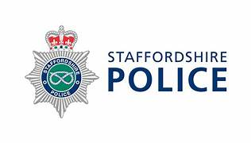

Mrs Nicola Oliphant
Headteacher
DSL

