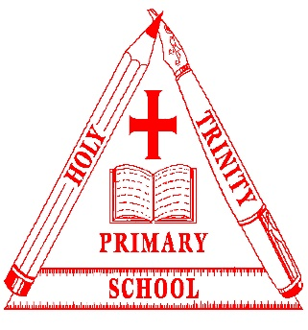
Holy Trinity
Child-friendly anti-bullying policy
At our school, we share values and beliefs based on Christian values. This school is a place where everyone has the right to be themselves. It’s a place where everyone can feel safe, be happy and learn. Everyone at our school is equal and acts with respect and kindness towards each other to link with our school values and Golden rules. We want to keep our school a bully-free place.
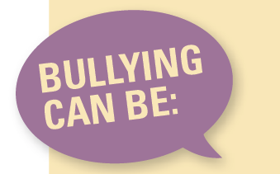
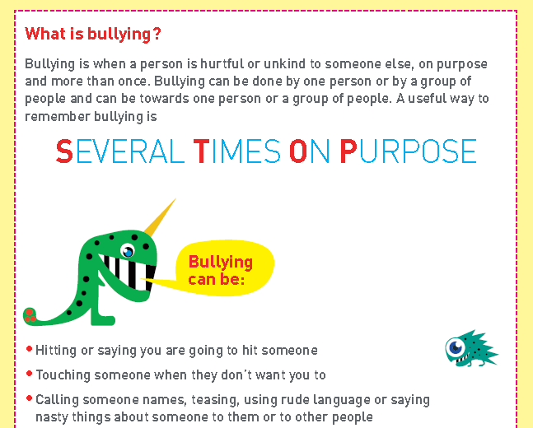

Remember words are as hurtful as actions: be careful with your words.
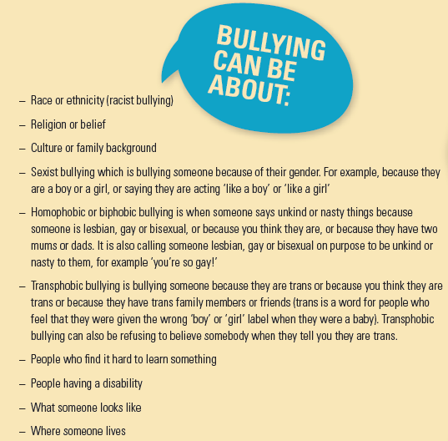

Why does bullying happen?
Although bullying doesn’t happen very much at this school, it might happen. Bullies can be older or younger than you, bigger or smaller than you. Bullies pick on people who may be different in some way and try to make them feel worse about themselves. If you are being bullied remember that it is never your fault.
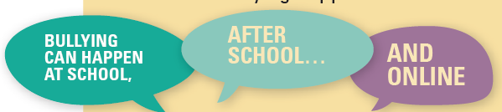
Where does bullying happen?

What should I do if I think someone is being bullied?
Talk to the person and ask if they’re ok and try to find out if they are being bullied. If they are, ask if you can help them talk to a teacher or an adult they trust.
What should I do if I’m being bullied?
If you are being bullied, it is important to tell someone you trust. Tell an adult or friends, either at school or at home. If you have already told an adult about bullying you can still tell them again. You can:
- Tell an adult in school – this could be your class teacher, LSA, a different class teacher, lunchtime supervisor, office staff, Head teacher.
- Tell a playground buddy, who will be able to help you to talk to an adult.
- Tell an adult at home.
- You could write a note about the bullying in the ‘I want my teacher to know…’ box.
If you tell a teacher or adult at school, they will be able to help you. They may tell another teacher like your class teacher, or a parent or carer so that they can help you. Telling an adult will never make the bullying worse. They will talk to you and the bully to find ways to stop the bullying.

