FS1 have crammed a lot into our first half term! Here are some of things we have been upto. I hope you enjoy looking at them.

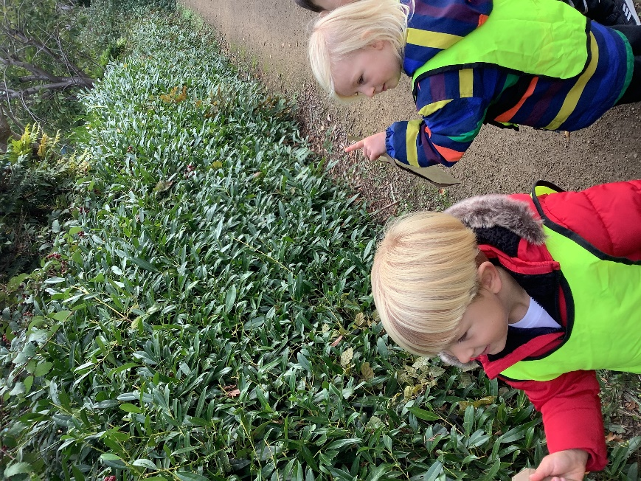

We have been on an Autumn walk. We spotted lots of different types of berries.
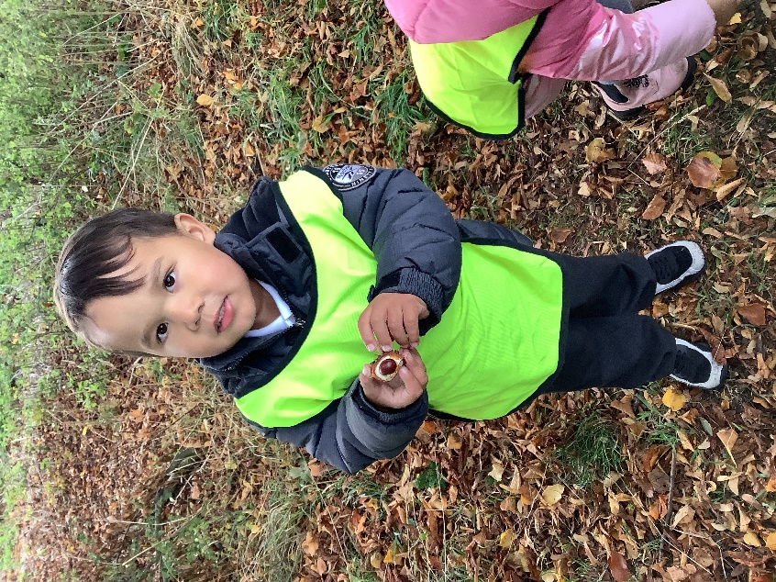
We searched everywhere for conkers!
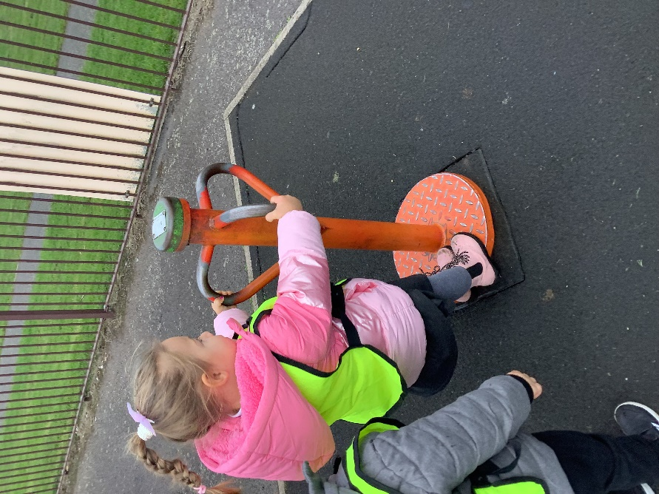
We even had time to play at the park! It was great fun trying out all of the equipment.

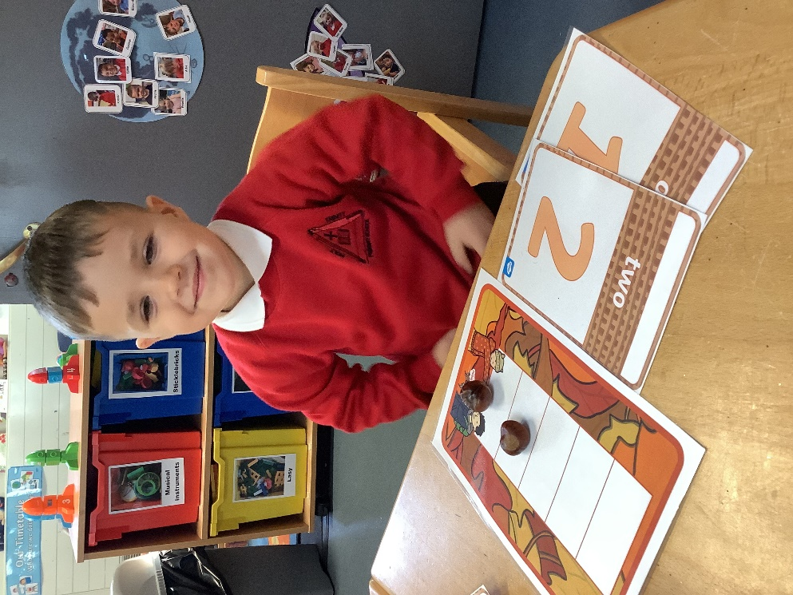
Our conkers came in handy for counting!
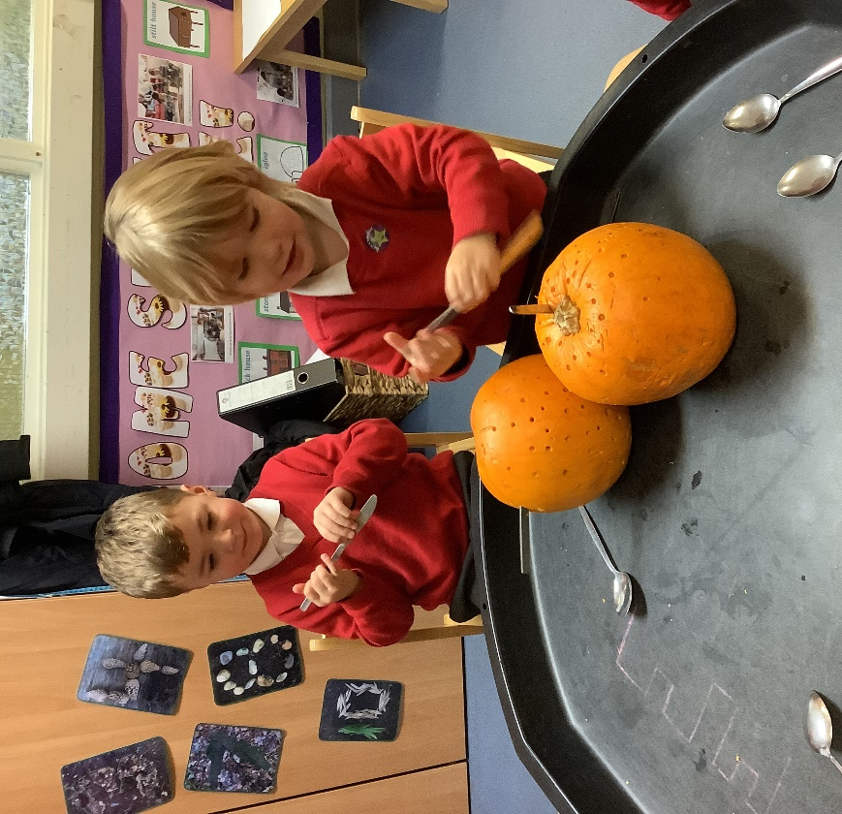
We really enjoyed exploring the pumpkins.

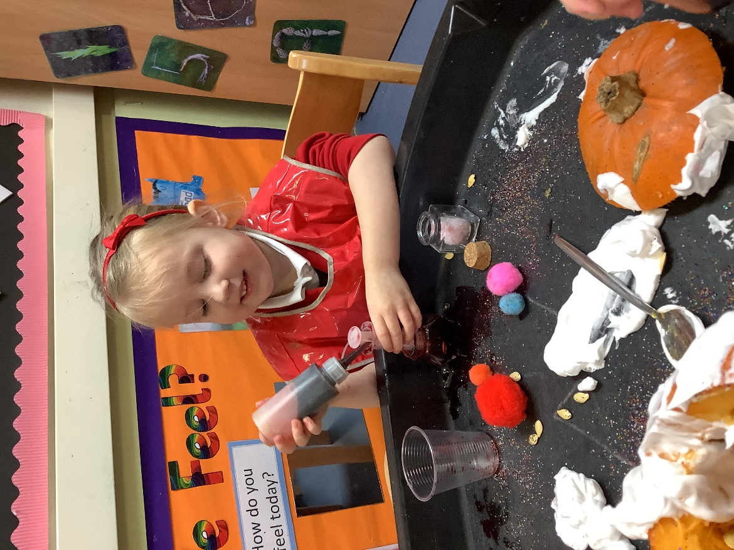
We had a potion station, it was great fun!

