
Holy Trinity CE (C) Primary School
Remote Learning Plan 2021-2022

Dear Parents/Carers,

Please find below the details of the remote learning plan on offer to pupils at Holy Trinity Primary School; to access the remote learning on your child’s Google Classroom area. All log ins and passwords have been sent home to you to access this area. Please note that if your child is isolating, the remote learning on offer should be completed where possible, just as if they were in school each day with us.

Remote learning opportunities which are always available:

Children will always be able to access the following online learning websites at home:

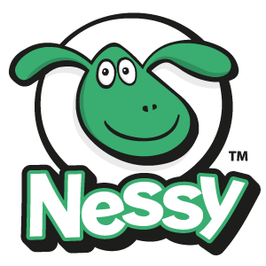
- Nessy (Year 1 -6 available for invited children) – fun ways to support with spelling knowledge


- Times Tables Rock Stars (Year 2 - 6) - a carefully sequenced programme of times tables practise to boost times tables recall.
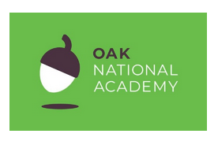
All below items are arriving after half term

- https://www.thenational.academy/ (all classes in school) vast range of learning videos and resources for the full curriculum



- SpellingShed (all classes in school) fun interactive games to support phonics and spelling patterns



- MathsShed (all classes in school) fun interactive games to support maths skills and knowledge

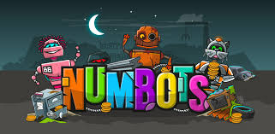

- Numbots (EYFS&KS1) - games aimed at boosting children’s recall and understanding of number bonds and addition & subtraction facts.


- OxfordOwl (EYFS&KS1) reading support at home

If your child is isolating, but the rest of their class is in school:

When required, teachers will upload the remote learning on offer onto your child’s Google Classroom area which will direct children to the work that is required for them to complete whilst they are off school. It will also identify any websites or video links (refer to the list above) that align to what the children are being taught in school. Children will be provided with one English lesson, one Maths lesson and one Wider Curriculum lesson per day.

Please do not use these links to pre-teach your child if they are in school as it may spoil some of the surprises the teachers have planned for the children. If your child is in school, there is no need to access this work, but you may find it helpful to see which areas are being covered.

If the whole of your child’s class is isolating:

Your child’s class teacher will provide one English lesson, one Maths lesson and one Wider Curriculum lesson per day (as we did during the National Lockdown). Children will also be provided with further links to access a Wider Curriculum lesson which will be aligned with the year group’s curriculum or be directed to any of the websites above. You can ask questions and feedback to the staff in your child’s class each day, just like during lockdown. Your child’s work needs to be uploaded each day to be marked and commented upon.

In the event of a lockdown forcing the closure of school:

50% of the staff will be in school with the critical workers’ children and 50% of the staff will be at home delivering remote learning - teachers will provide one English lesson, one Maths lesson and one Wider Curriculum lesson per day (as we did during the National Lockdown). Children will also be provided with further links to access a Wider Curriculum lesson which will be aligned with the year group’s curriculum or be directed to any of the websites above. You can ask questions and feedback to the staff in your child’s class each day, just like during lockdown. Your child’s work needs to be uploaded each day to be marked and commented upon.
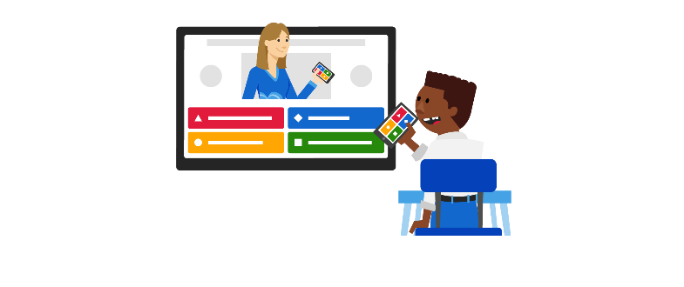

*If your child’s class teacher is unwell, work will be added by members of the staffing team for your child each day.

Attendance during isolation or lockdown

Please note that school may need to put into place restrictions on attendance at school for all/selected bubbles of children due to COVID-19 related issues and restrictions. These restrictions will not affect your child’s attendance/unauthorised absences for the year but may change according to current/national/local needs.

However, if your child has to isolate or quarantine from school (i.e. if they are isolating/quarantining following a holiday to a restricted destination, if they are isolating due to the family being required to do so following track and trace, if a bubble at school has a confirmed COVID-19 case and has had to close, if local or national lockdowns are implemented) then they will be required to complete their Remote Learning each day, as if they were in attendance at school. The only exception to this is if they are actually ill; you will need to phone school as you would report illnesses as if your child were in the ‘actual building’. Not completing Remote Learning will result in your child having unauthorised absences and will follow the same guidance as above.

I would like to reassure you that the education and health and safety of all our children and staff is our utmost priority and will take all appropriate measures whilst your child is in school or if they are accessing their remote learning.

September 2021
Mrs Nicola Oliphant
Headteacher

