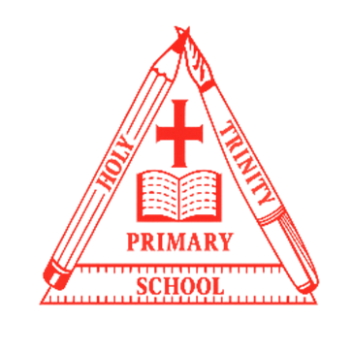
Year 1
Curriculum NEWSLET TER
LOGO
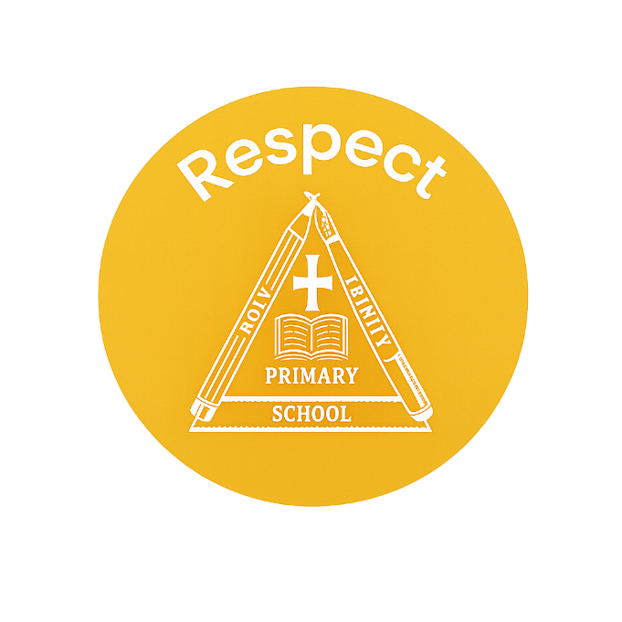
Class teacher’s Message
Maths Learning
We are focusing on our understanding of place value to 10. We will use different methods of counting and different resources to help us learn. We will also be learning how to add and subtract numbers within 10.
English Learning
In English we will be reading the book Mixed by Arree Chung, a colourful story. The children will explore different emotions based on the book and develop their own character descriptions. We will also explore poetry and write our own Mixed inspired poems.
“Once you learn to read, you will be forever free.” – Frederick Douglass
Welcome to this half-term in year 1.

Teachers and adults working with the children are Miss Bowley and Mrs Parker.

INSIDE THIS NEWS

Please read with your child every day and sign their reading diaries. They have a reading for pleasure book and a banded phonics book.
It’s important to fail in our learning!
Reminders
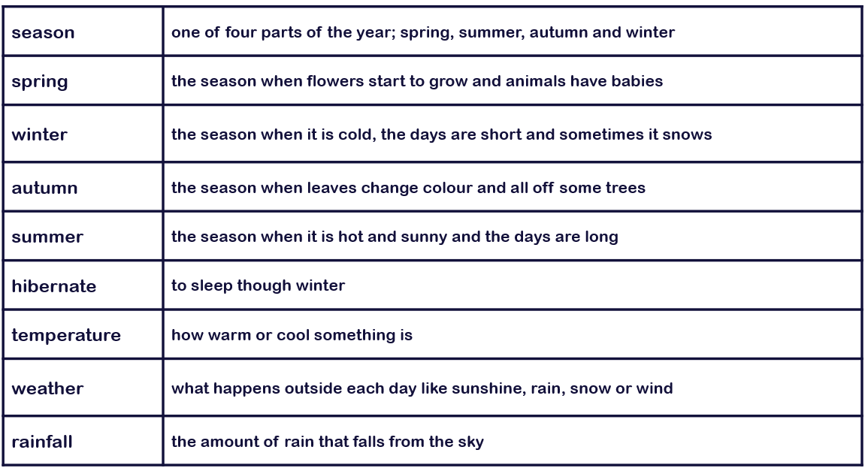
Key Vocabulary
History/Geography Learning
This term, we are studying History. We are learning about how we are making history. The children will be investigating the past within living memory by exploring personal chronology and using photographs to ask and answer questions about the past.

Science Learning
In Science we are learning about the four seasons. The children will learn how to observe changes across the 4 seasons and observe and describe weather associated with the seasons and how day length varies.
Spelling test Day
Key Days
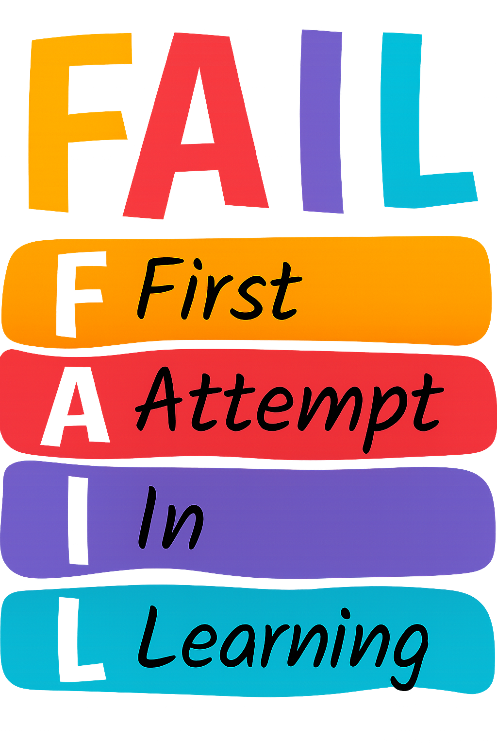

PE Day/s

- Friday
- Tuesday and Friday

