
Curriculum NEWSLETTER
Reception
LOGO
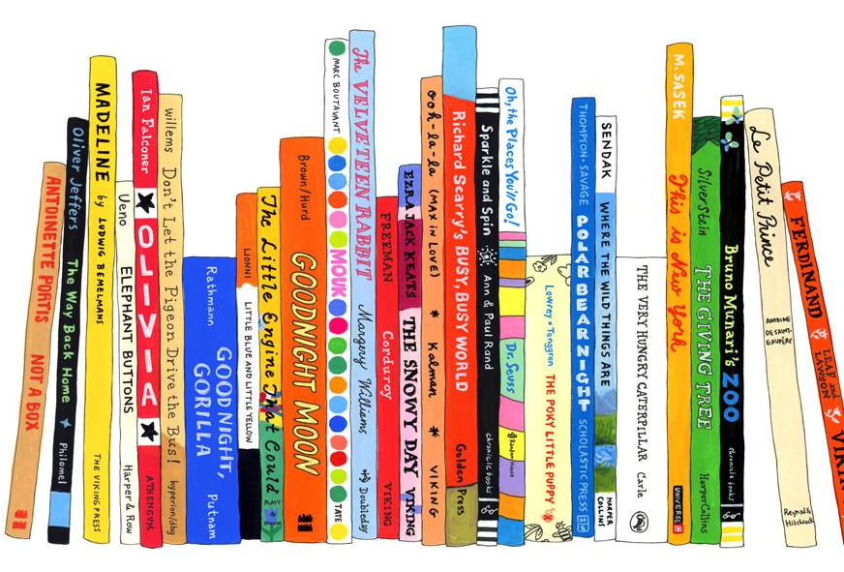
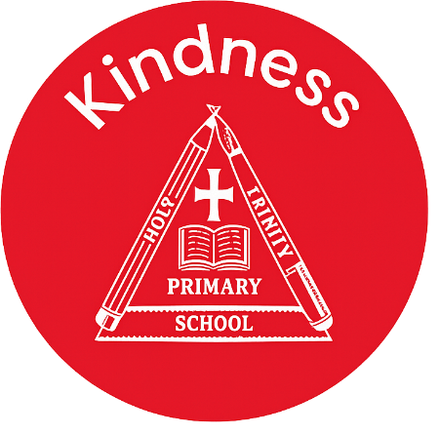

Maths Learning
In maths we have been exploring which objects were heavier and which were lighter. We estimated which objects would be heavier and which would be lighter and used scales to check if our estimations were correct! We also explored how to make the scales balance by placing an object on one side and using cubes on the other until the scales balanced. We enjoyed exploring!
We also filled a selection of different sized containers with water- always thinking which could hold the most. We placed the containers in order from the smallest to the greatest capacity.

Welcome to this half-term in Reception!
From,
Mrs Taylor, Mrs Whetton and Miss McSherry
Class teacher’s Message
English Learning
In phonics we are learning phase 3 phonemes including ‘ow’ for cow and ‘oa’ for boat.
Our topic is all about space and we are sharing ‘Whatever Next’ by Jill Murphy. Can you discuss the beginning, middle and end of the story? Can you discuss the characters and setting too?

“The more that you read, the more things you will know. The more that you learn, the more places you’ll go.”
– Dr. Seuss

INSIDE THIS NEWS
Key words –
Can you help your child to read these words every day and point to them?
- he
- she
- be
- we
- you
Key words
Reminders
Please remember to bring your child with a spare set of named clothes, a water bottle and also a bag each day. Thank you
- Inset Day – school closed Monday 26th January
- Moo Music – Friday 30th January
- Break up for February half term – Friday 13th February.
PSED Learning
The children will be continuing their learning using My Happy Mind. This program is helping to teach the children about feelings and emotions. It is also a great tool for the children to understand their brain and how to have a healthy mind and body.

Understanding the World Learning
We will be teaching the children all about space and the historical figure Neil Armstrong! Can you find any space facts and bring them to school? We would love to share them!

It’s important to fail in our learning!
Key Dates
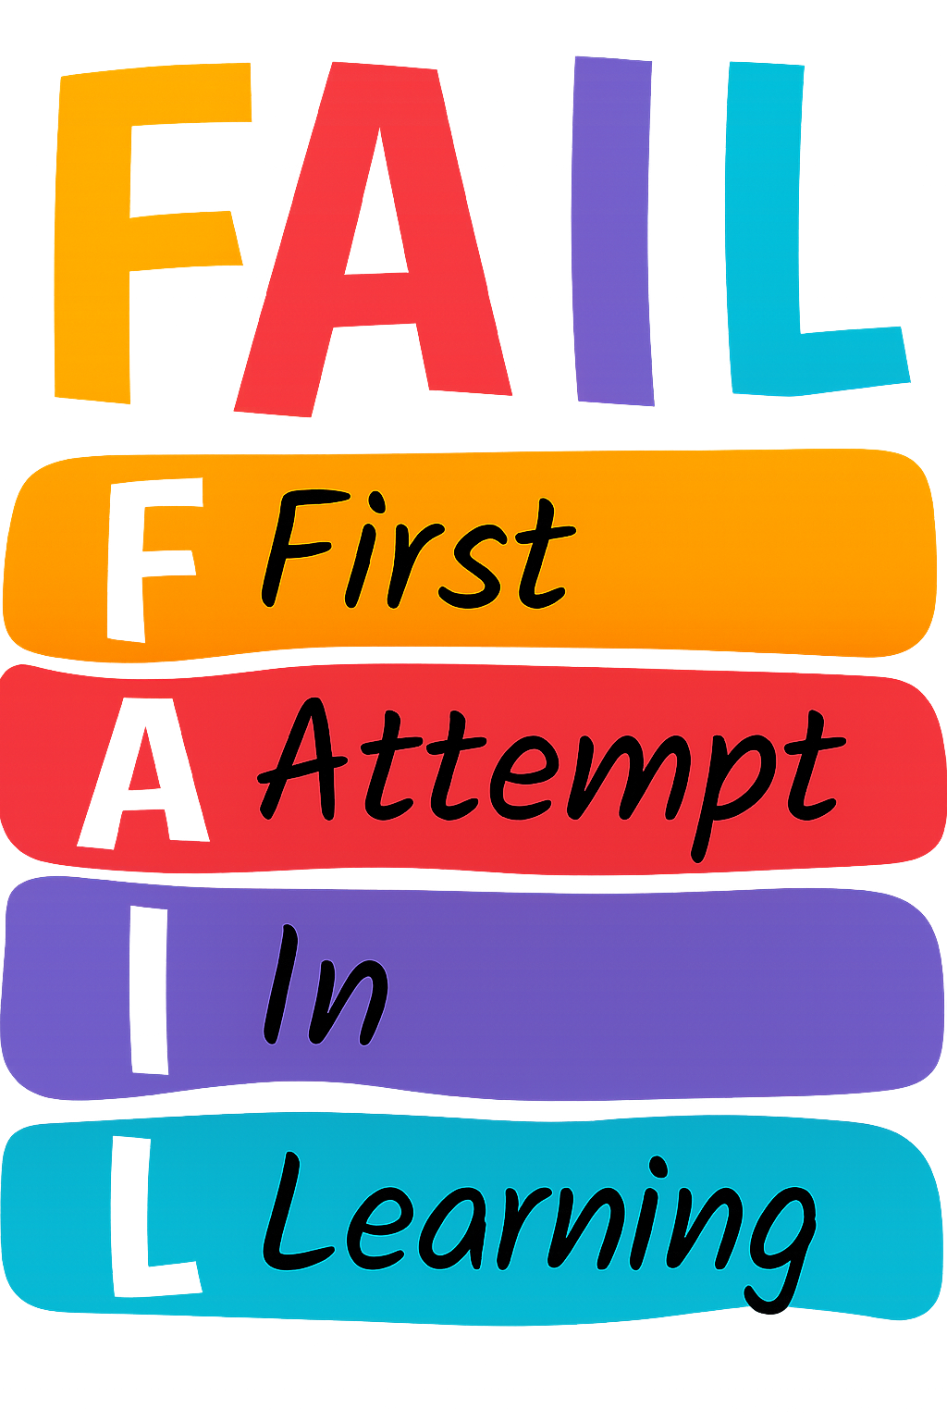

PE Day

- Friday morning

