
Curriculum NEWSLETTER
Summer Term 2
Year Reception
LOGO

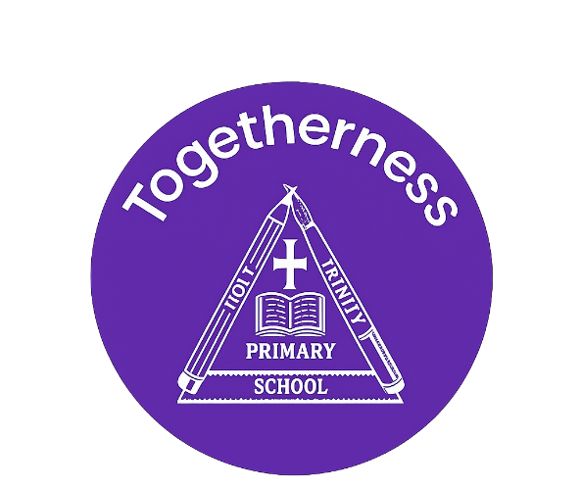
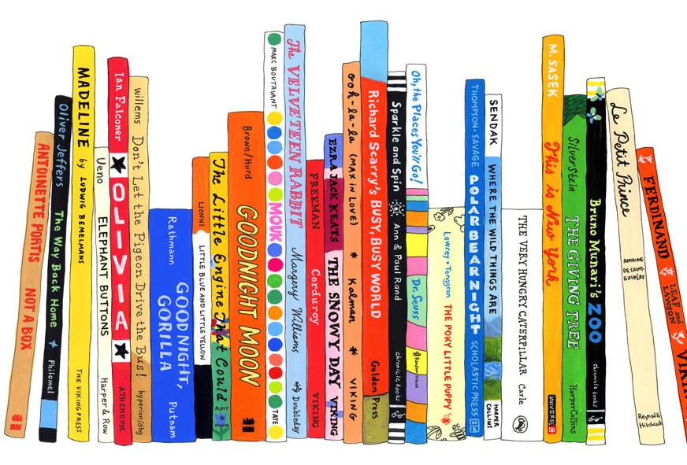
Maths Learning
- To have a deep understanding of numbers to 10, including how numbers are made (composition)
- To subitise up to 5 (recognise quantities without counting)
- To recall number bonds:
- Securely to 5
- Some to 10 (including doubles)
In Reception we like to keep the learning practical and offer the children resources to support them. For example, cubes or buttons!
Welcome to this half-term in Reception

Teachers and adults working with the children
Mrs Hoskins
Mrs Taylor
Miss McSherry
Mrs Hamnet

Class Messages
English Learning
- Read simple texts with increasing independence
- Understanding what they read (comprehension)
- Writing simple sentences using their phonics skills to support them and to check their writing for capital letters, finger spaces and full stops.
-to identify 10 diagraphs. For example, ‘oa’ as in ‘boat’ and ‘ow’ as in owl.
This term we focusing our literacy learning on the text, ‘Jack and the Beanstalk.’
“Reading is a passport to countless adventures.” – Mary Pope Osborne

INSIDE THIS NEWS

- Thursday 25 June Transition Reading Time with new teacher
- Thursday 2 July Whole School Transition Morning
- Week beginning 6 July 2026, Meet the Teacher Transition Afternoon
- Friday 26th June Sports Day from 12 pm
- Tuesday
PE Day/s

- plant
- grow / growing
- seed
- soil
- water
- sun / sunlight
- leaf / leaves
- flower
- root
- stem
- life cycle

Expressive Arts
-Observational drawings of plants- adding detail. For example, the stem, leaves and flower
-Use natural objects to create collages
-Sponge printing of leaves
-Cutting and sticking of petals to create flowers
-Explore the Garden Centre role play area
-Singing growing songs. For example, ’I’m a little seed.’
- Moving like growing plants (stretching up tall, curling like seeds)

Knowledge and Understanding of the World
- To label the parts of a plant
- To identify what plants need to grow
- To describe changes when they plant seeds and observe the plant grow
- To look after plants and understand that they are living
It’s important to fail in our learning!
Key Rocket Words

Key Days


