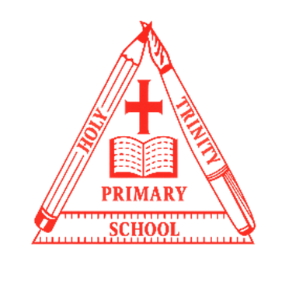
Year 1
Curriculum NEWSLETTER
LOGO
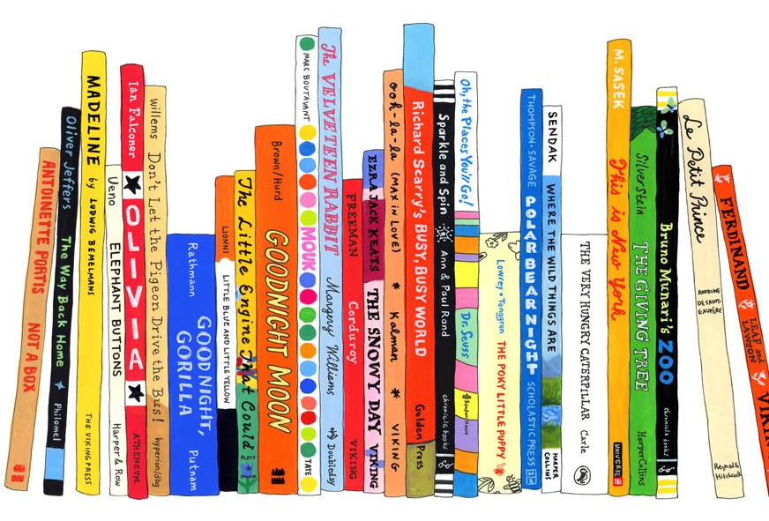
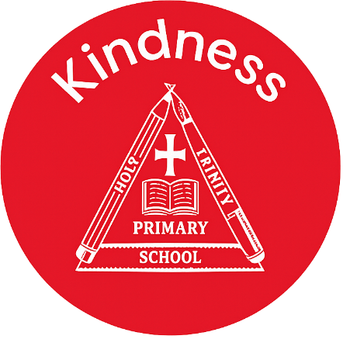
Class teacher’s Message
Maths Learning
The children will be understanding numbers within 20 and later on to 50. Our lessons will help us to order, compare and place them on a number line. We will also be learning addition and subtraction within 20.
English Learning
In Year 1, the children will be learning about The Three Little Pigs and understanding how and why the big bad wolf decided to blow their houses down. The children will re-write the story and then write a letter to the big bad wolf.
We will also be reading The Great Explorer and becoming innovative writers by changing parts of the story.
w

“The more that you read, the more things you will know. The more that you learn, the more places you’ll go.”
– Dr. Seuss

Welcome to this half-term in year

Teachers and adults working with the children are Miss Bowley and Mrs Parker

INSIDE THIS NEWS

Remember to read to get your rainbow read badges.
It’s important to fail in our learning!
Reminders
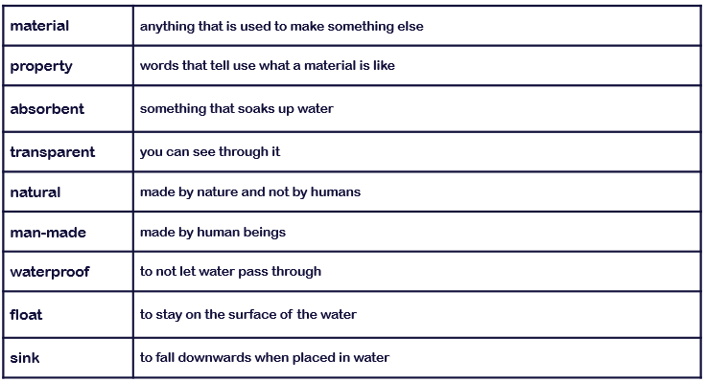
Key Rocket Words
Topic Learning
In History we will be learning all about our personal histories and how we are making history every day. We will be understanding chronology, timelines and how our childhood compares to children of the past.
In Geography we will be learning about the human and physical features surrounding our school.

Science Learning
In Science, we are learning about the properties of every day materials. We are learning to identify where we find these materials and what we can use them for.
Spelling test Day
Key Days
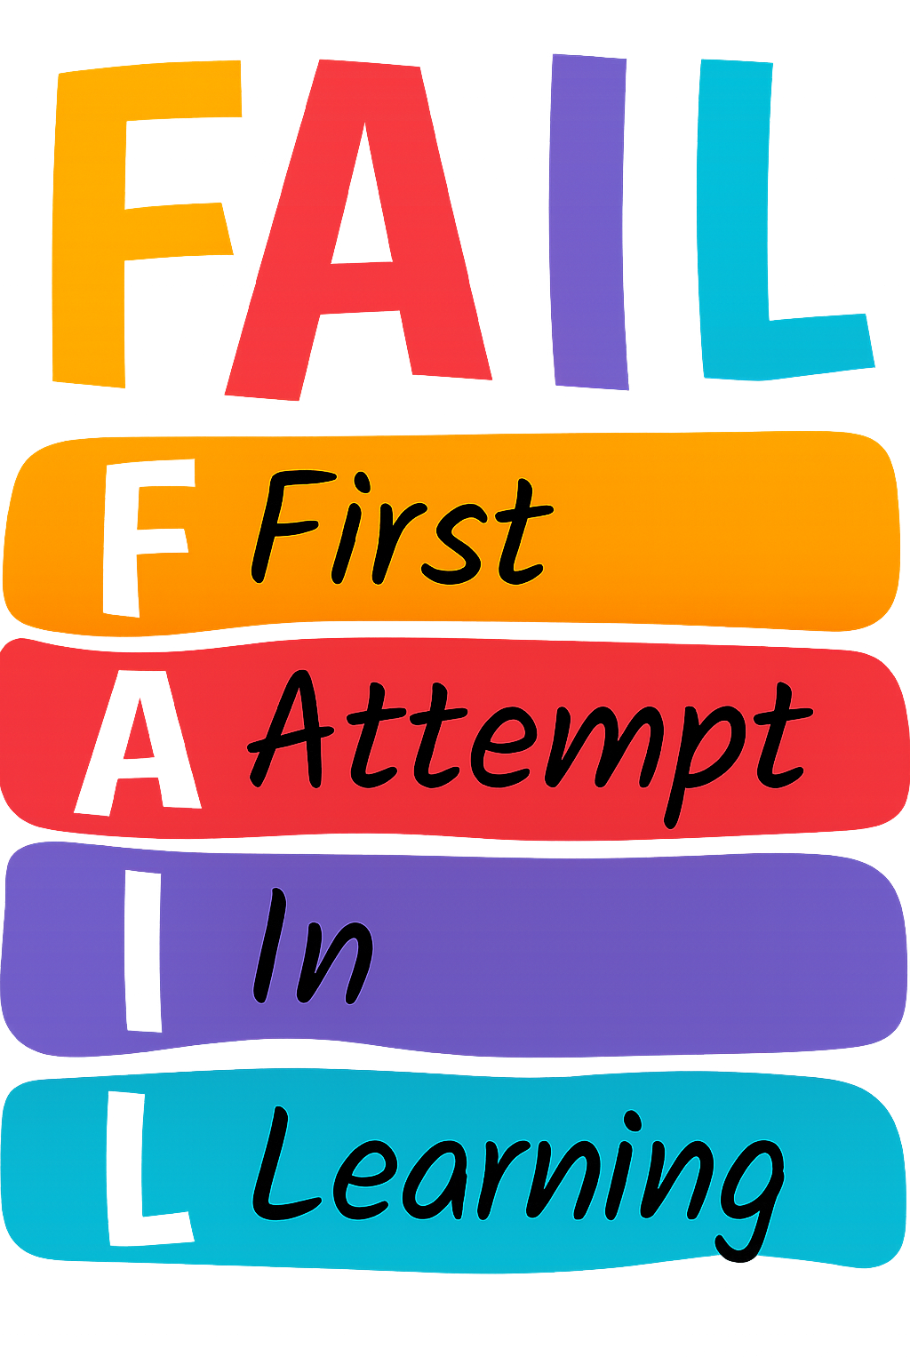

PE Day/s

- Fridays
- Wednesday
- Thursday

