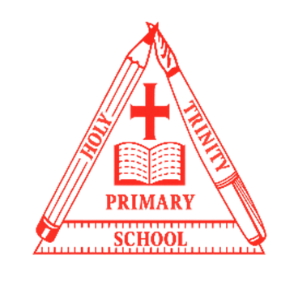
Year 2
Curriculum NEWSLETTER
LOGO
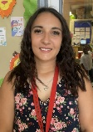
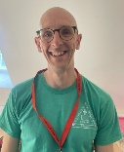
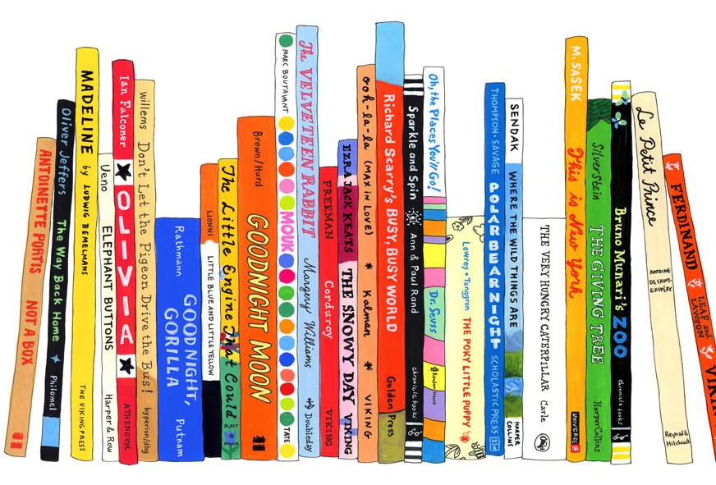
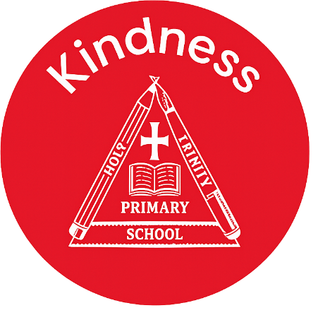
Class teacher’s Message
Maths Learning
Our Maths lessons will begin by recognising, counting and calculating with money. We will then move onto multiplication and division. We will begin to learn how to multiply and divide by 2, 5 and 10 and then learn our 2, 5 and 10 times tables. We will be using arrays to help us understand this.

English Learning
In English we will continue to focus upon developing our key skills in reading and writing. To begin with we will be exploring dragons and working towards writing our own information reports on our own dragons. We will be using our retrieval skills and inference skills to develop our reading comprehension.

“The more that you read, the more things you will know. The more that you learn, the more places you’ll go.”
– Dr. Seuss

Welcome to this half-term in year 2

Teachers and adults working with the children are Mr Hoskins and Miss Park

INSIDE THIS NEWS
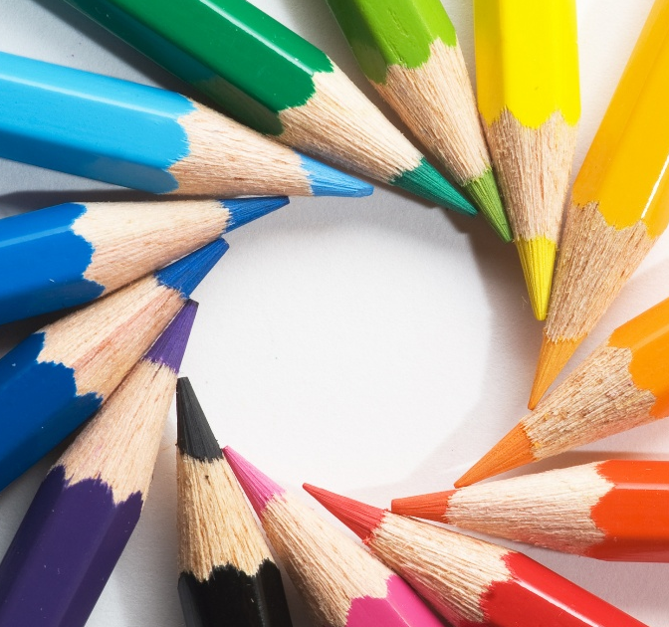
It’s important to fail in our learning!
Reminders
material property obstacle construction
stretchy elastic force bend

beyond living memory inventor lifetime source
Key Rocket Words
History/Geography Learning
Our History learning will be focussed on the origins of light. We will begin by looking at the Wright brothers and when the first flight was. We will then understand why Bessie Coleman and Amelia Earhart are historically significant. Later we will investigate why the Moon landing was a significant event in history.

Science Learning
In Science, we will be focusing on materials. We will first recap our learning from Year 1 and identify the materials from which everyday objects are made. We will classify materials based on our own criteria and we will think about the properties of materials that make them suitable or unsuitable for particular purposes.

Spelling test Day
Key Days
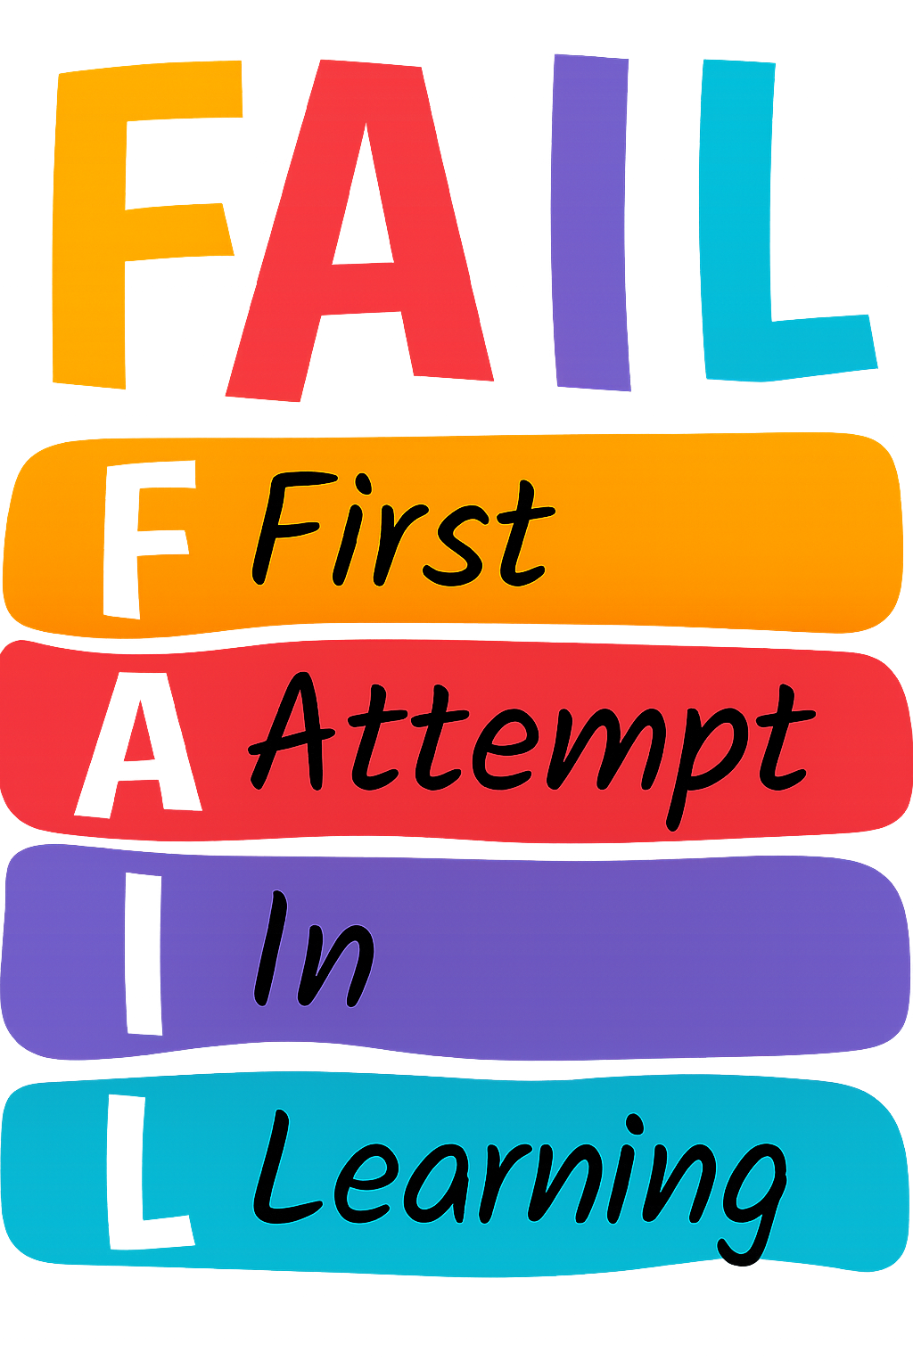

PE Day/s

- Friday
- Monday and Thursday

